S_PL0_86000030-G/L ACCOUNT BALANCES (NEW)


This simulation describes how to use T-Code S_PL0_86000030 G/L Account Balances (New).

Please note that in S/4 there are several CDS Views available for displays of G/L balances, which are more user friendly and flexible than the S_PL0* reports. It is recommened that you consider using those CDS Views to meet your business needs.

Click to continue to learn details of S_PL0_86000030 report.

Explanation | Screenshot
[1] Follow SAP menu path: Accounting->Financial Accounting->General Ledger->Information System->Account Balances->General->G/L Account Balances  to find T-Code S_PL0_86000030 - G/L Account Balances (New) and double click it.  Or type the T-Code directly in the Transaction Box.  is now double-clicked. | 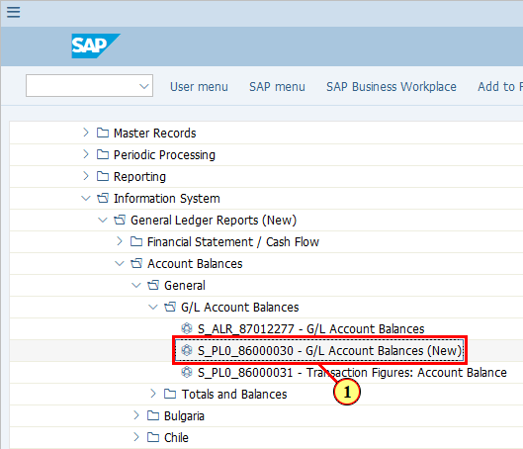
[2] The *Currency Type field is filled out.  You can fill in a single value or a few different values.  These are the Currency Types we use:  - Curr. Type 00 - Document Currency (DC)  - Curr. Type 10 - Company Code Currency (LC1)  - Curr. Type 30 - Group Currency Legal Valuation (LC2)  - Curr. Type 31 - Group Currency Group Valuation (LC3, only available in Ledger 0L) | 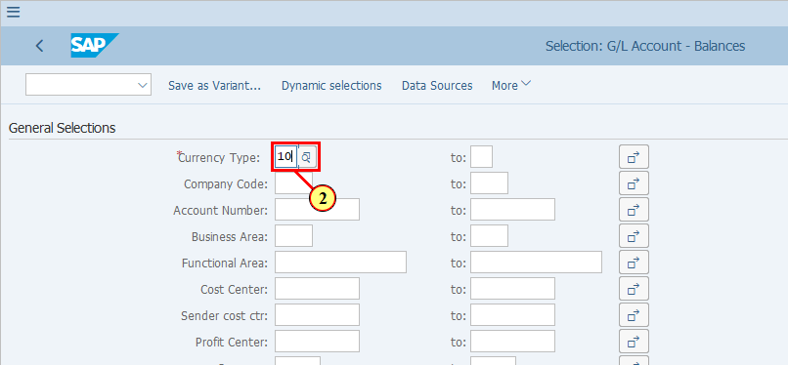
  In this demonstration we intend to display more than one currency types. This is done by inputting more than one Curr. Type values using the Multiple selection icon. However you can see that an error message has been issued.  [3] Click Multiple selection . | 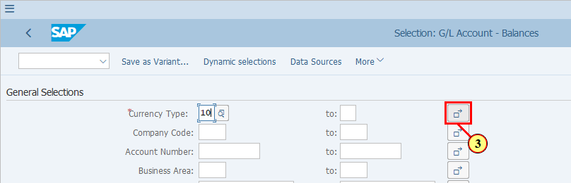
  As per the message, the system has deemed that you have entered a value in the first mandatory field, i.e. Currency Type, therefore you should continue to enter values for the rest of the mandatory fields, which are in the Report selections section.  As a result we will have to fill in the selection values in the Report selections section before moving back to the Currency Type field, where we want to enter more values. | 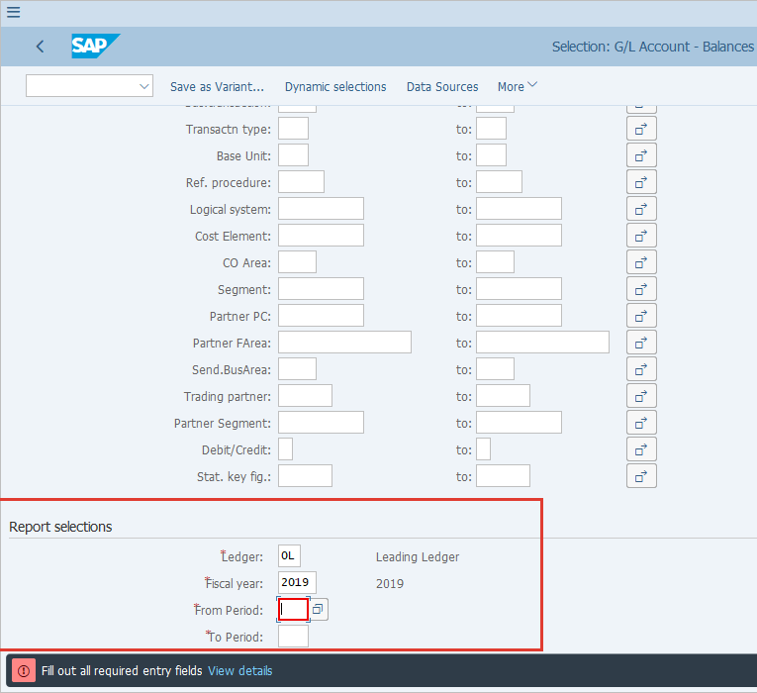
[4] The *Ledger field is filled out.  Note that only one ledger can be selected at a time in this Account Balance report. Ledger comparison is available in CDS Views. | 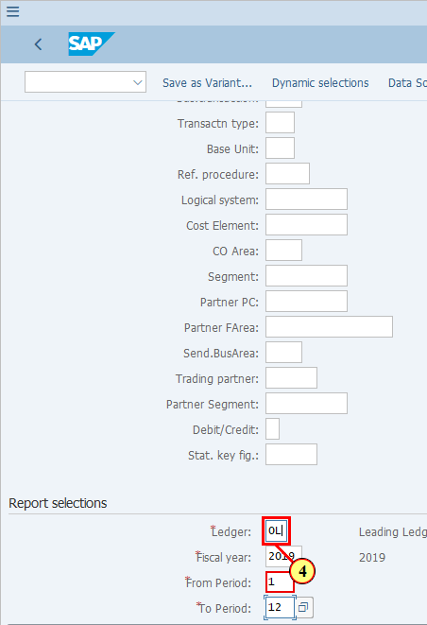
[5] The *Fiscal year field is filled out. | 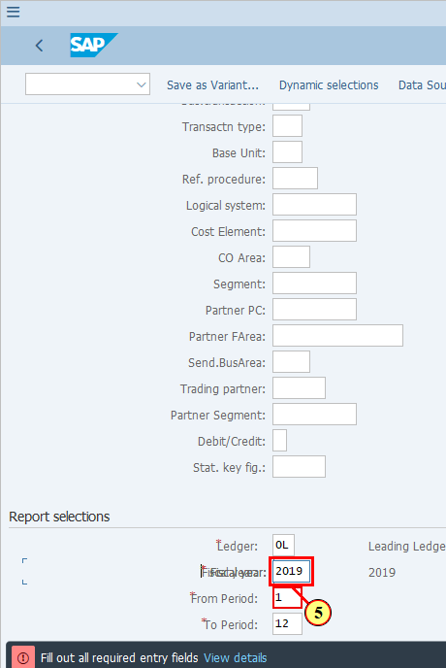
  Note that this report does not provide comparisons between different periods. Comparisons are available in CDS Views JTI Trial Balance report.  [6] The *From Period field is filled out. | 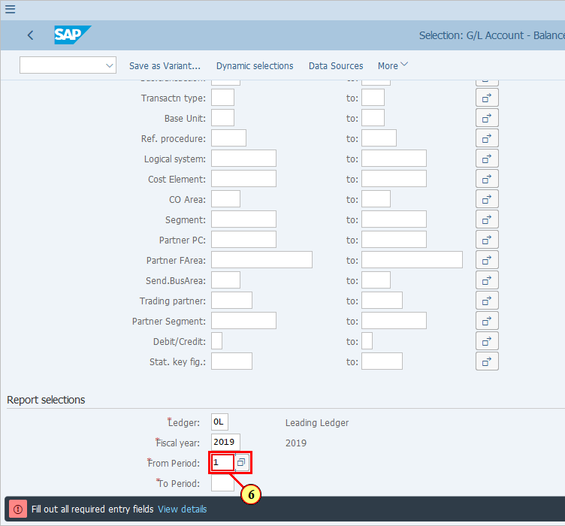
[7] The *To Period field is filled out. | 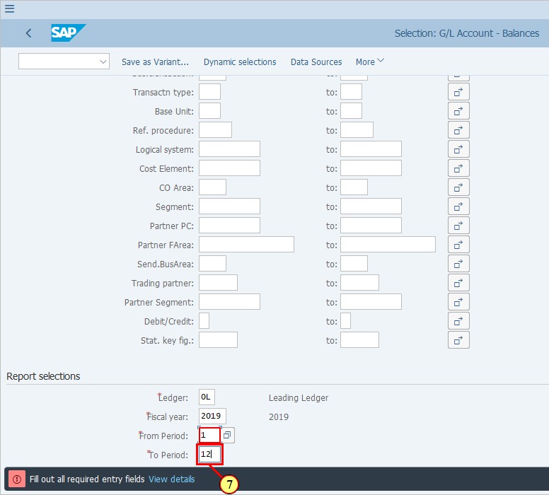
  Now we can go back to the Currency Type field, where we wanted to enter more values.  [8] Click Multiple selection . | 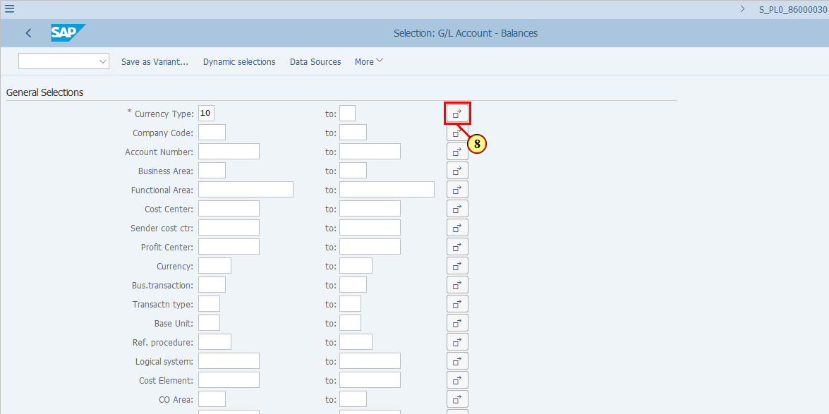
[9] The Single value field is filled out. | 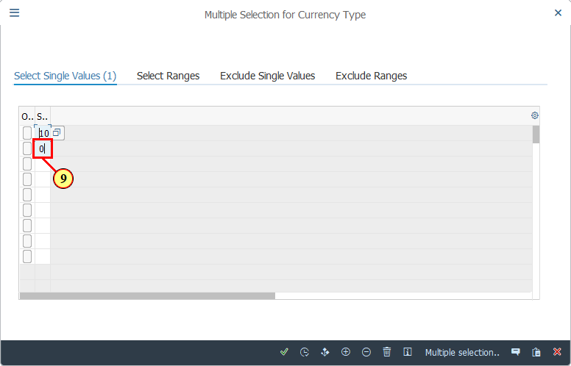
[10] The Single value field is filled out. | 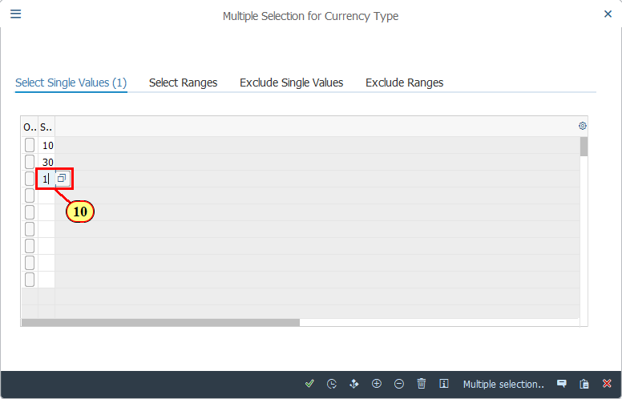
[11] Click Copy .  You can also press F8. | 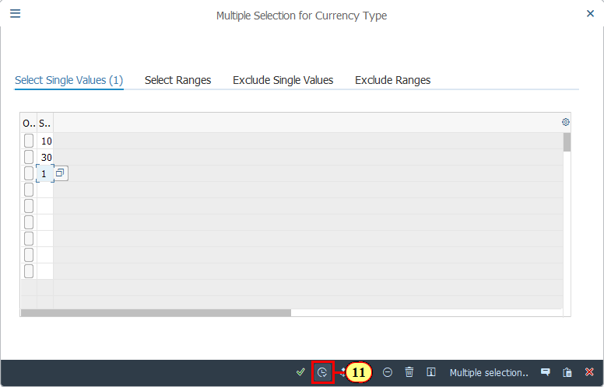
[12] The Company Code field is filled out. | 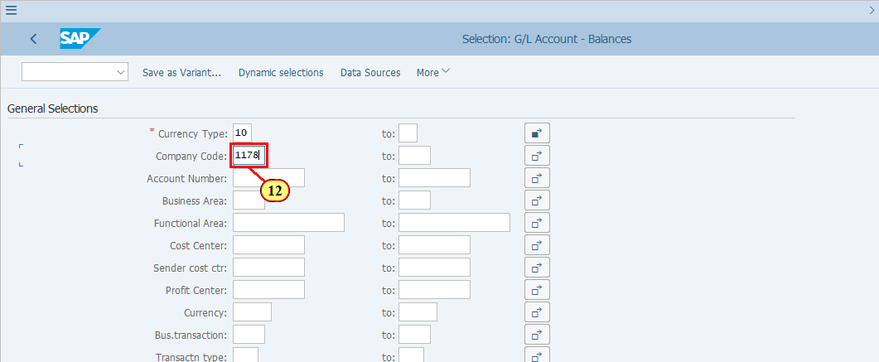
  The key improvement in this report, as compared to the ECC standard Account Balance report, is that you have the option to further restrict your data using many more characteristics (selection criteria). For example, you can select Account Balances for not only specific account numbers, but also for specific Profit Centers, Cost Centers, Functional Area, etc.  In this demonstration we have not restricted values in these optional fields but you may find it can be useful one day. | 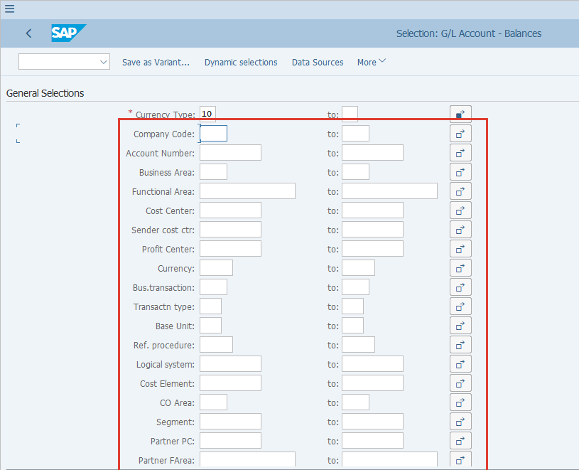
  Please note that in the current version of S/4, this option is not working. Therefore this report will not be able to display G/L balances based on Alternative Account Number even if you have selected this checkbox.  There are however other SAP standard reports, as well as CDS Views, which allow you to display report based on Alternative Account number. | 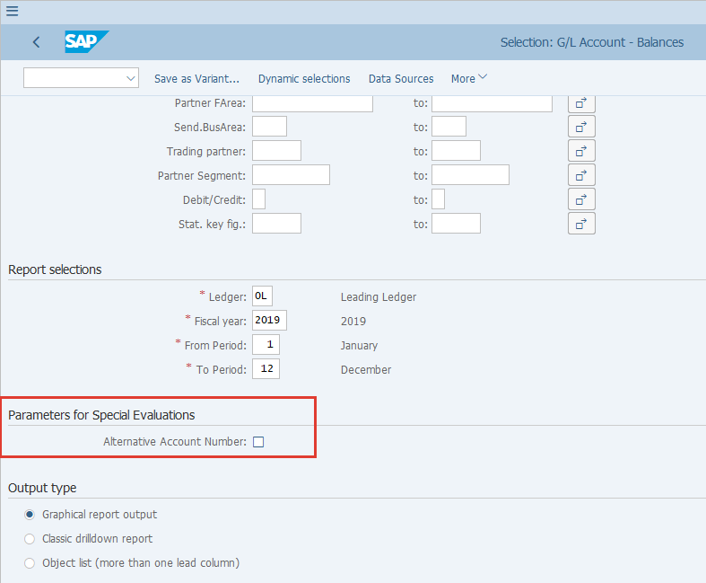
  If you wish to restrict your G/L accounts selection based on certain parameters in the G/L Master record, you may use the Dynamic selections button.  [13] Click Dynamic selections .  You can also press Shift+F4. | 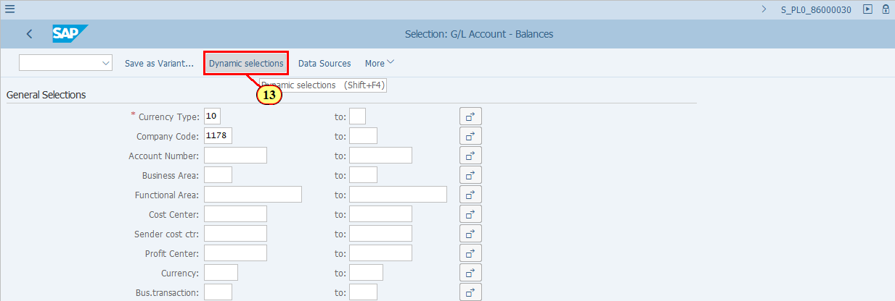
[14] Clicking the 'Close folder' icon closes the folder GL Account Master Record.  This folder contains G/L Master Record parameters at Chart of Accounts level, i.e. JTIO level. | 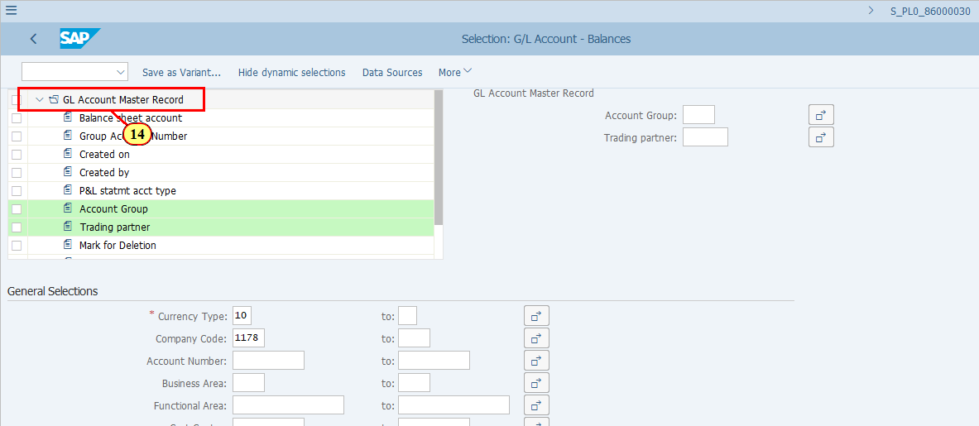
[15] Click Company Code .  This folder contains G/L Master Record parameters at company code level. | 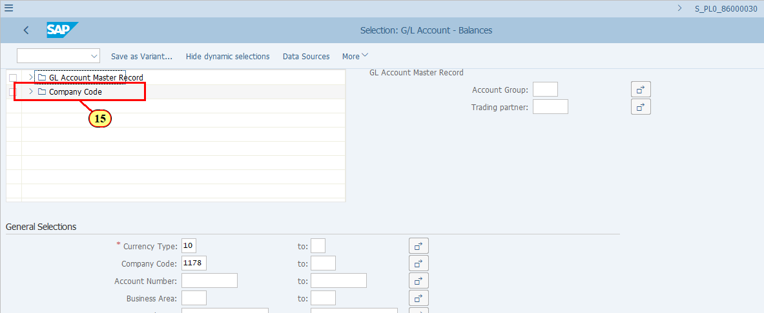
[16] To use one of the G/L Master Record parameters as a selection parameter, double click it and it will be shown on the right hand side of the screen.  Recon. Account for Acct Type is double-clicked. | 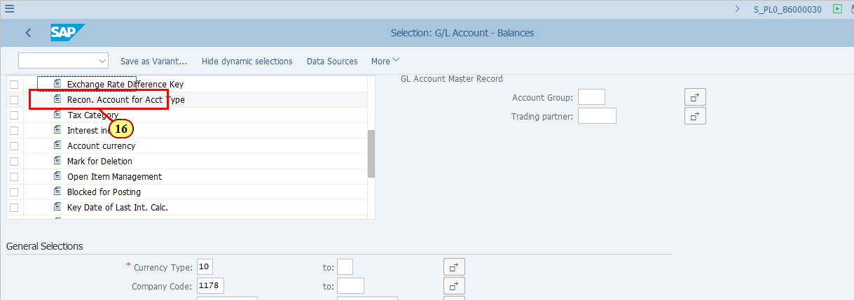
[17] You can fill in the values for your selection here.  The Recon. Account for Acct Type field is filled out. | 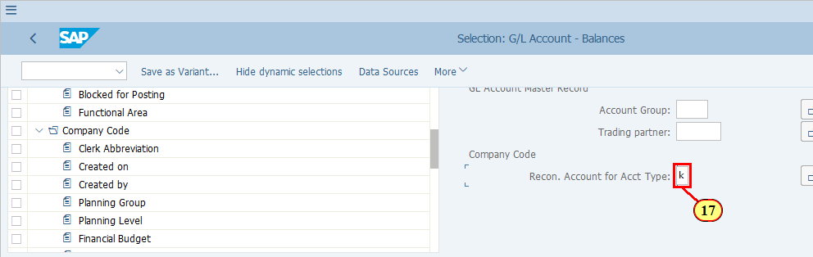
  There are three Output types available. Below is the SAP definitions for them.  - Graphical report output: You use the graphical report output if you want the report data to be displayed attractively on the screen or if you require several views of the report data simultaneously (drilldown list and detail list, for example).  - Classic drilldown report: You use classic drilldown reports if you require a high level of performance (for reports which analyze a large volume of data, for example) or if you want the report data to be printed.  - Object list: You use object lists if you want to display the corresponding characteristic values for every report line. Object lists present the only possibility of displaying several characteristics simultaneously in the lead column, with the value combinations of the report characteristics multiplied together. For this reason, object lists are often considerably larger than classic or graphical reports using the same quantity of data.  In practical terms, the first two output types are interactive with a Navigation pane allowing you to select and filter the data, while the Object list is more like a table with several lead columns. You may download your report from any of these output types.  Click to continue.  [18] Classic drilldown report is now selected. | 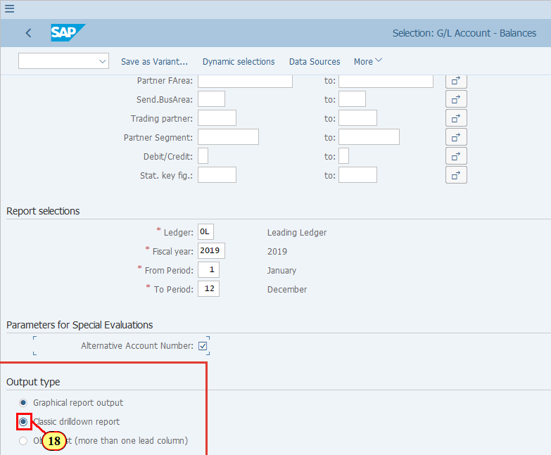
[19] Click Execute .  You can also press F8. | 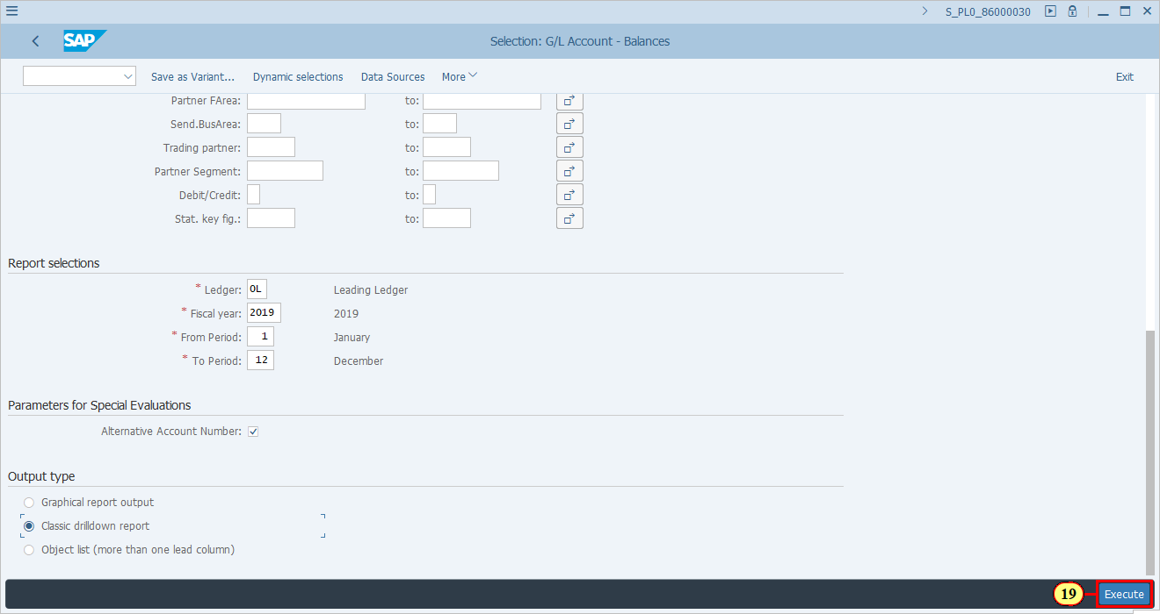
  The Navigation pane lists all the characteristics (fields) available for the data you display. To see which characteristics are available, use the small black triangles on the scroll bar to move up and down.  If a characteristic is selected to be displayed as leading column, that characteristic will disappear from the list in the Navigation pane. | 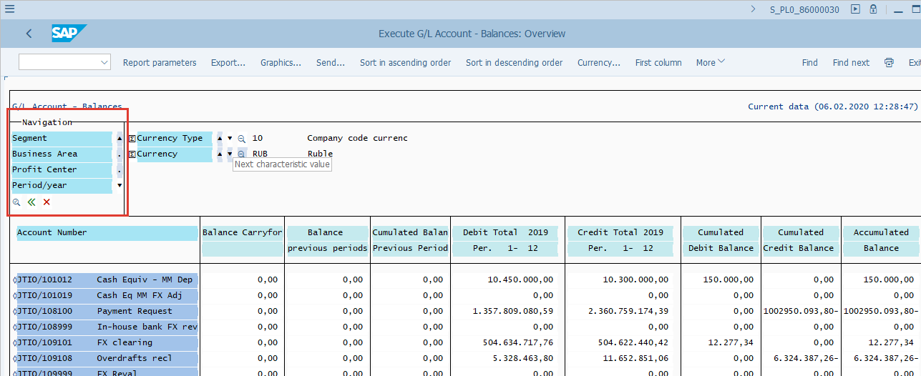
  This area shows which characteristics are being filtered.  Use the small black triangles to move up and down to filter with different value of the selected characteristic.  [20] Click > . | 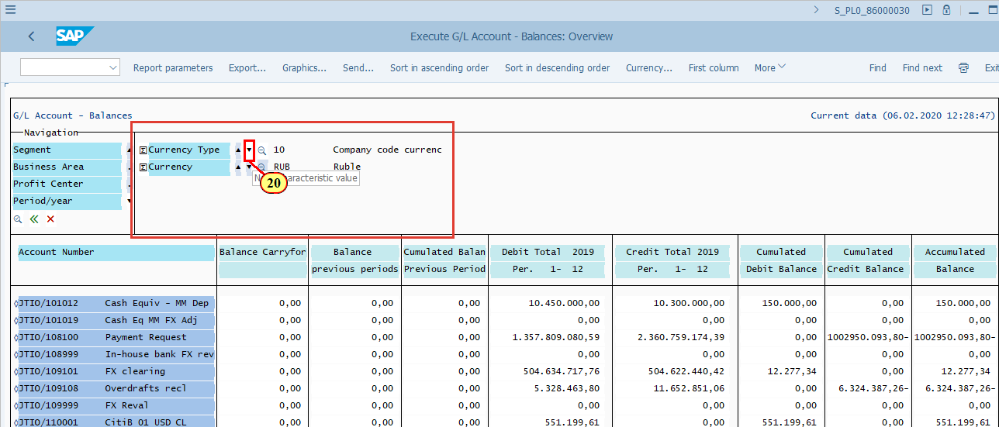
[21] If you see this screen, press ENTER.  Or you can click on Never display again if you do not wish to see it again. | 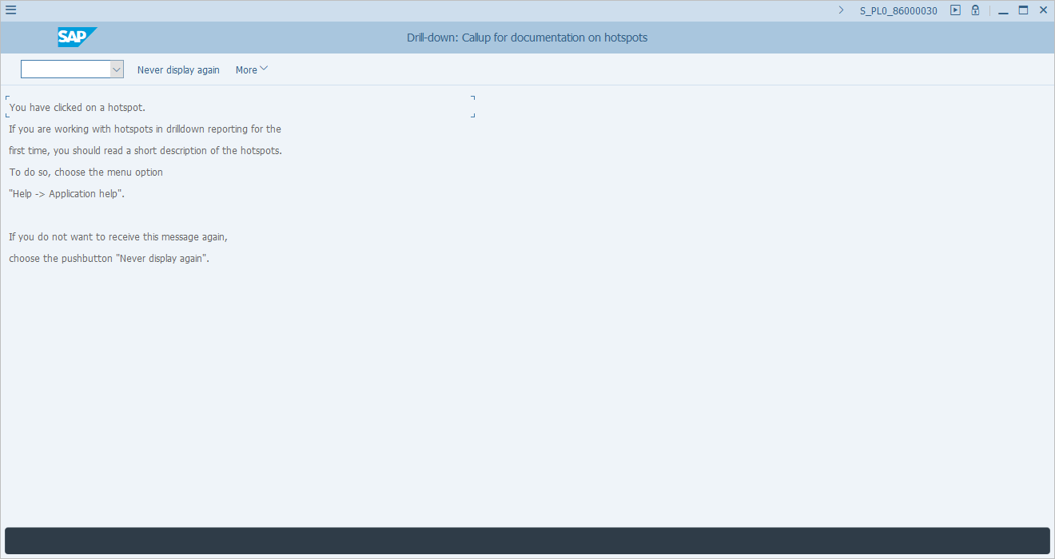
  As you can see in this example, the data is refreshed when you filter for Currency Type 30. Let's try to move down by one more value - Curr Type 31.  [22] Click > . | 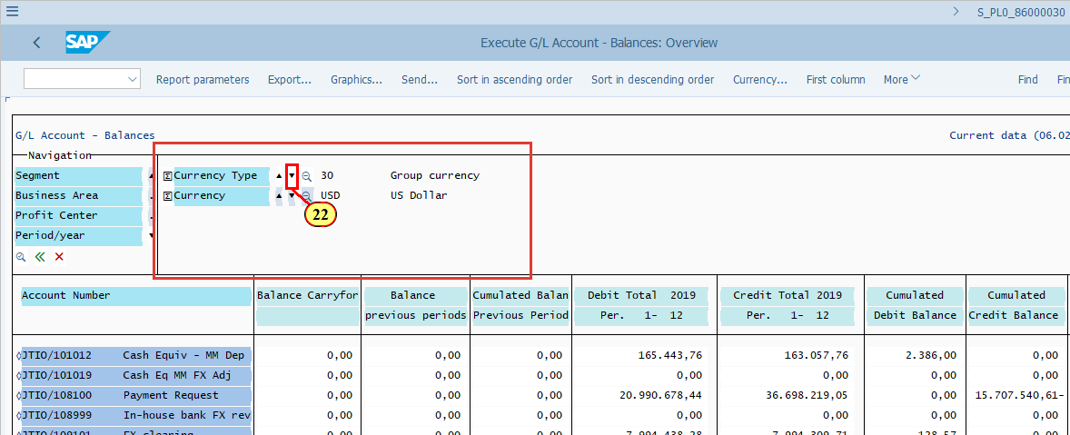
  As you can see, the data is refreshed when you filter for Currency Type 31. | 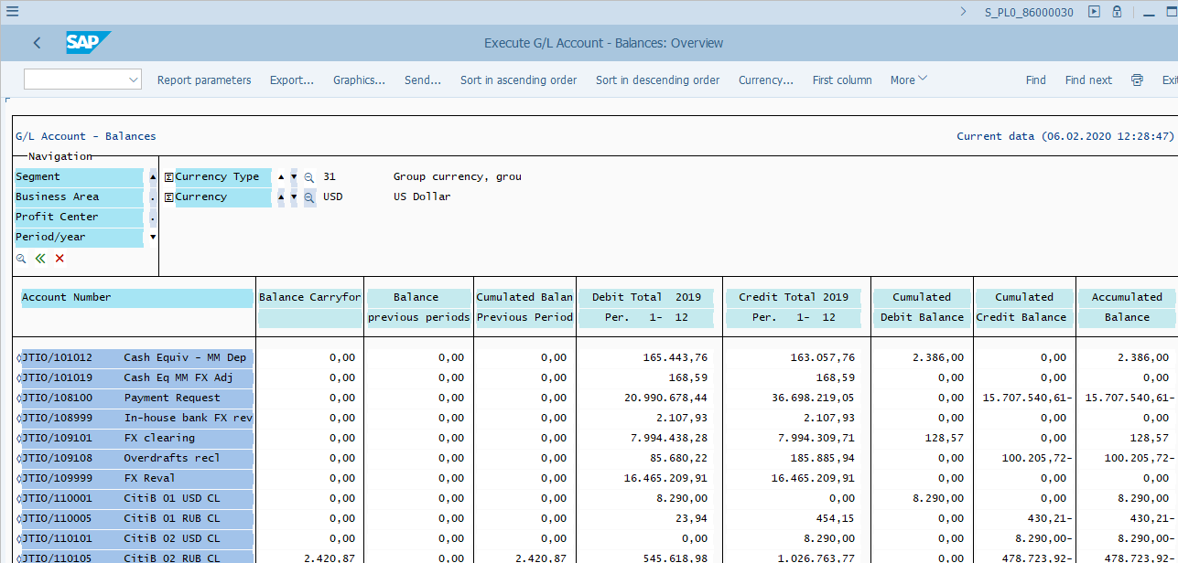
  You can filter the data using additional characteristics.  In order to do so, your report should first be displayed using that characteristic as Lead column.  As shown in our example, currently Account Number is the lead column. To filter for specific values of Account Number, simply double click on that value. E.g. we should click on the row for JTIO/101012 to filter for the result that belongs to this JTIO only.  [23] Cash Equiv - MM Dep is double-clicked. | 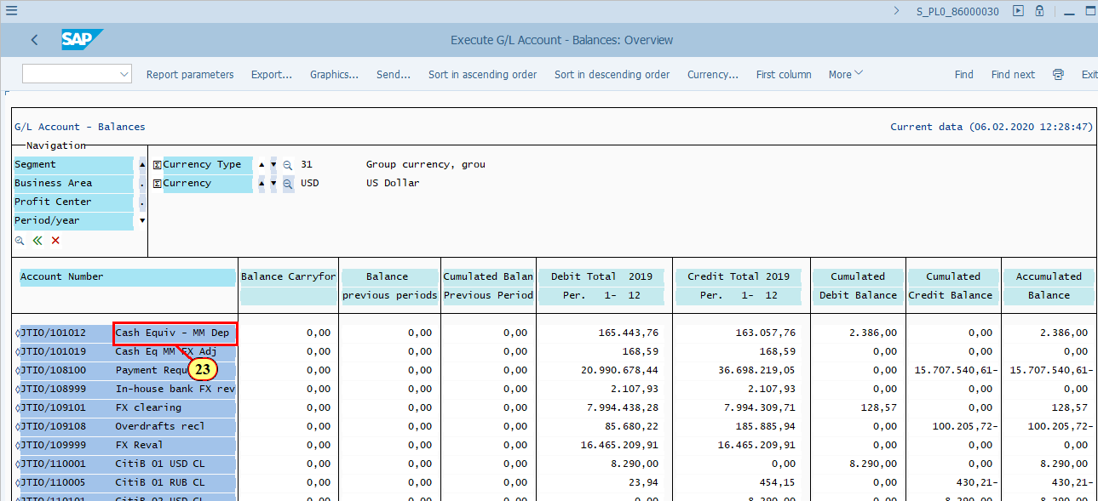
  As you can see, the data is refreshed with the filter of characteristic Account Number, value JTIO /101012.  To see the result of other Account Numbers, use the small black triangles to move up and down.  You should also notice, that once we have moved Account Number to the filter section, the Lead column of the report has changed to "Segment". This happened automatically because Segment was the next characteristic listed in the Navigation Pane. The report has to be displayed with one Lead column, therefore it took the next available one.  [24] Click > next to Account Number to display the data filtered for the next JTIO account. | 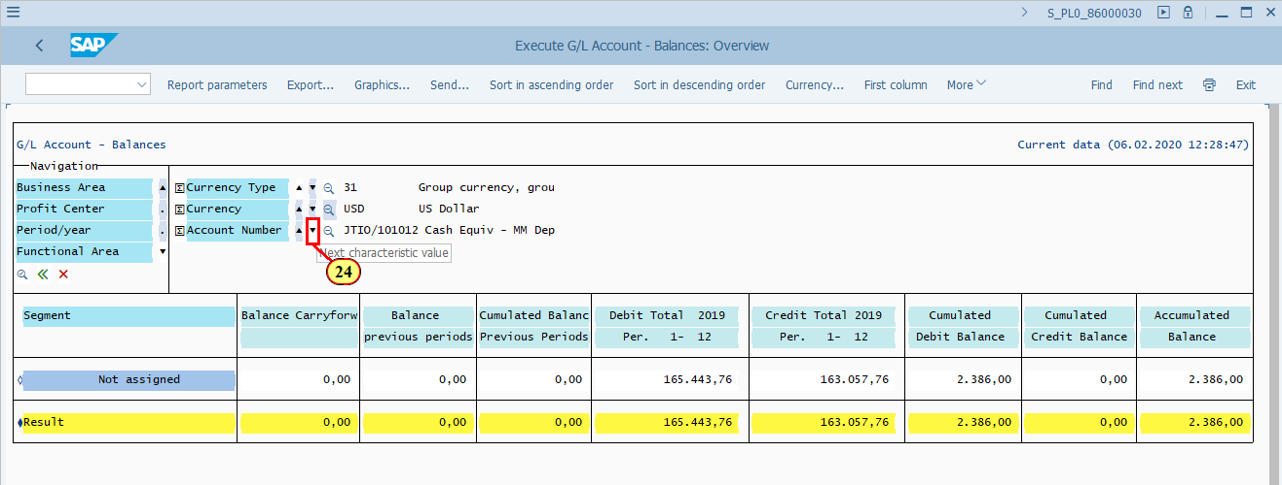
  Note the change of data after your filtering criteria have changed.  Now let's have a look at how to put the characteristic Account Number back to the report so that the report is shown with Account Number as Lead column again.  [25] Click Account Number . | 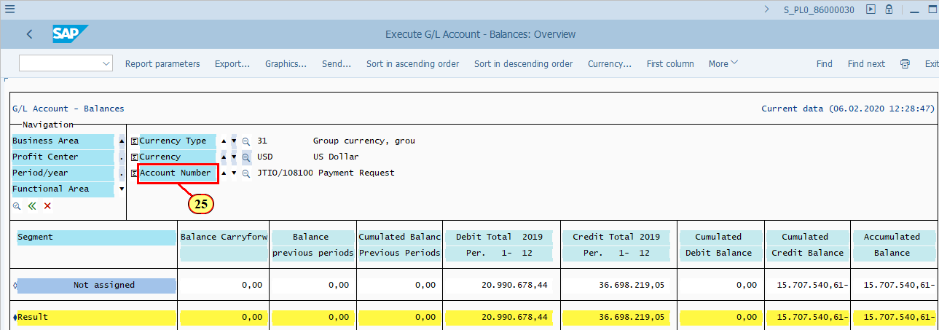
[26] Click Go back . | 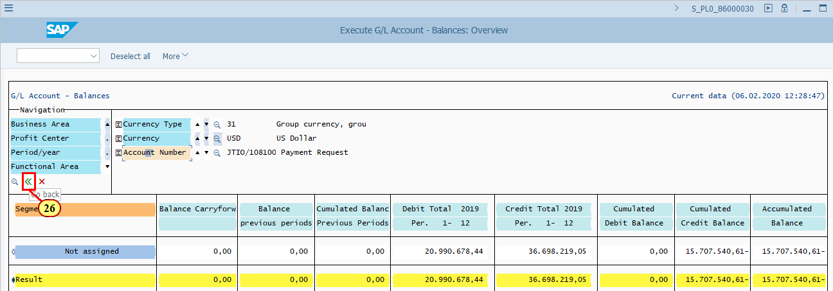
  Now the report is shown with Account Number as Lead column. | 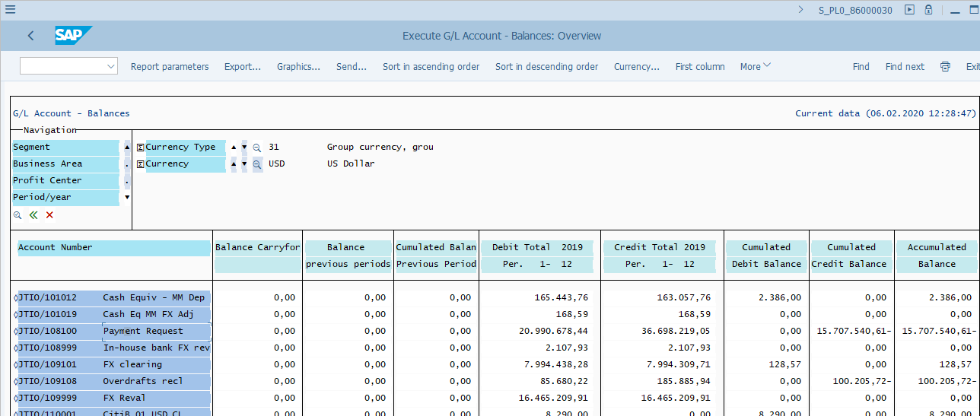
  How to move a characteristic from Navigation pane to Lead column of the report?  [27] Click Profit Center . | 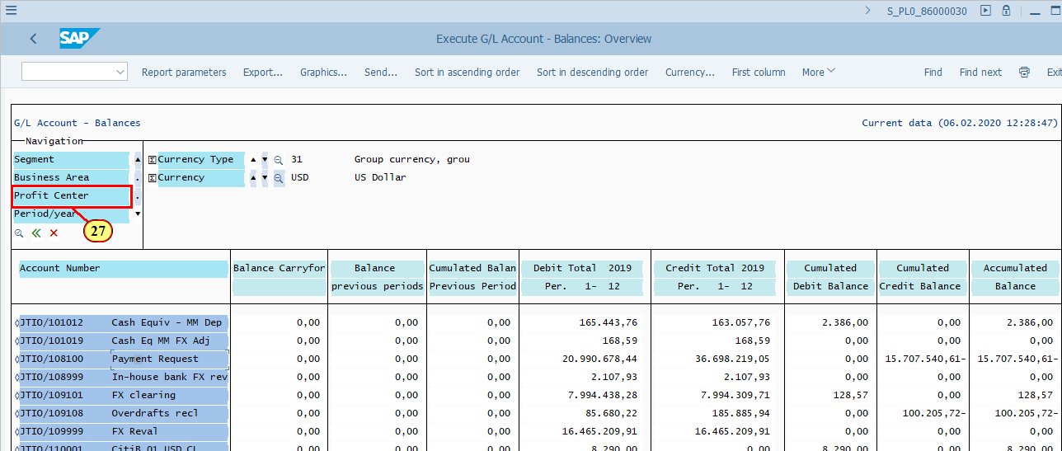
[28] Click on the current Lead column: Account Number . | 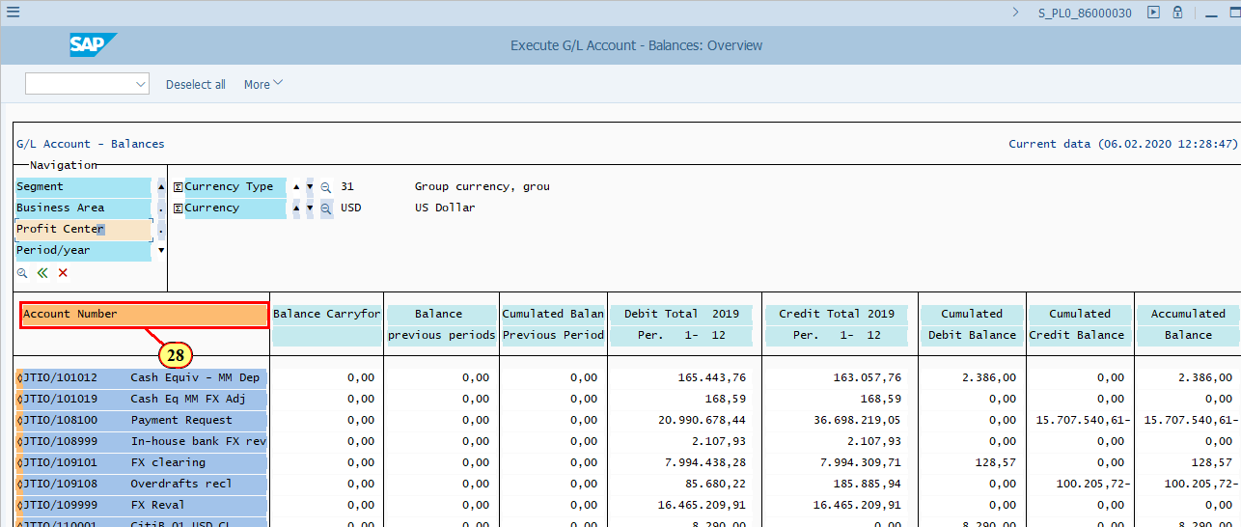
  As you can see that Profit Center has replaced "Account Number" to become the new Lead column of the report.  To find where characteristic Account Number has gone, click on the black triangle in the Navigation pane, you will see that "Account Number" has returned to Navigation Pane.  [29] Click > . | 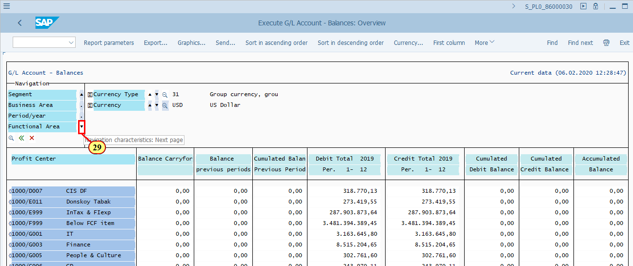
  Account Number has returned to Navigation Pane.  You may now filter for Profit Center by double clicking on one of the Profit Centers as it is now the Lead column of the report. | 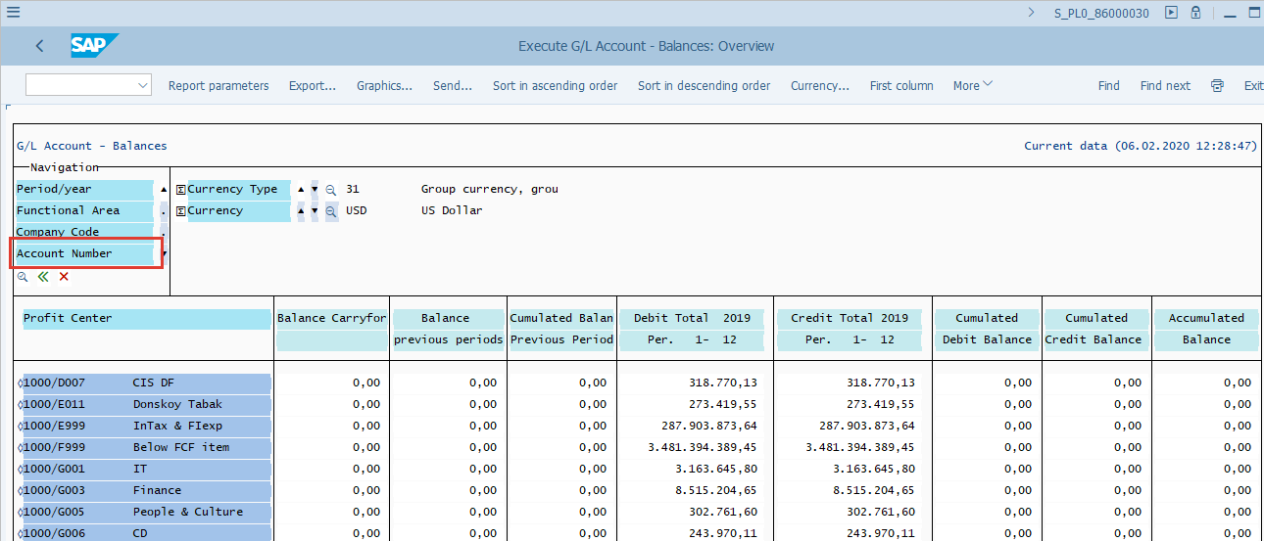
  Drilldown report functions  There are many different functionalities in the classic drilldown report in SAP. You may take time to explore them. In this demonstration we will briefly explain the functionalities which may be used by end users more often.  [30] Click Report parameters .  You can also press Ctrl+Shift+F12. | 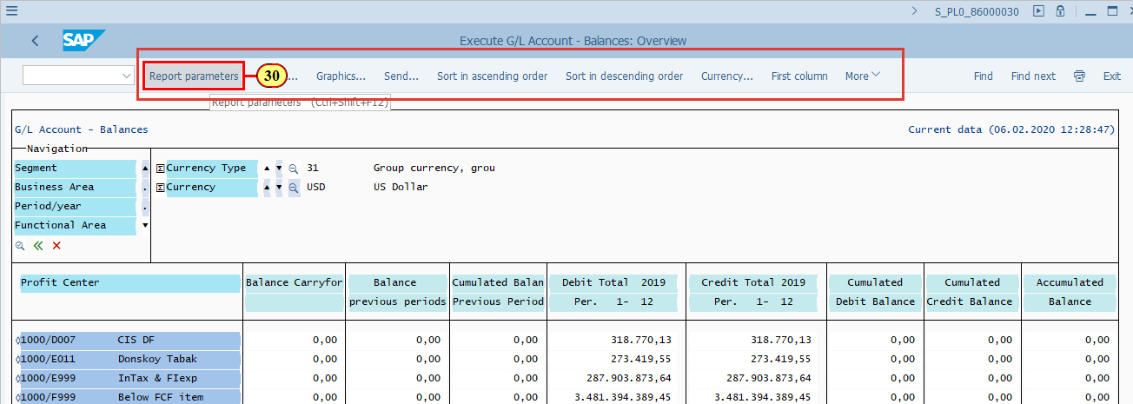
  Report Parameters  This is a display of the basic information of the report, including what you have selected to display and some technical information of the report definition itself.  You normally do not need to check such information.  [31] Click Back .  You can also press F3. | 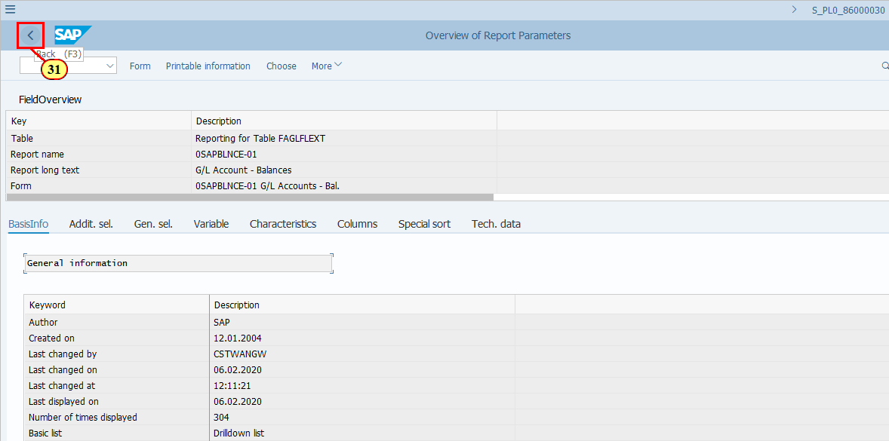
[32] Click Export... .  You can also press Ctrl+Shift+F11. | 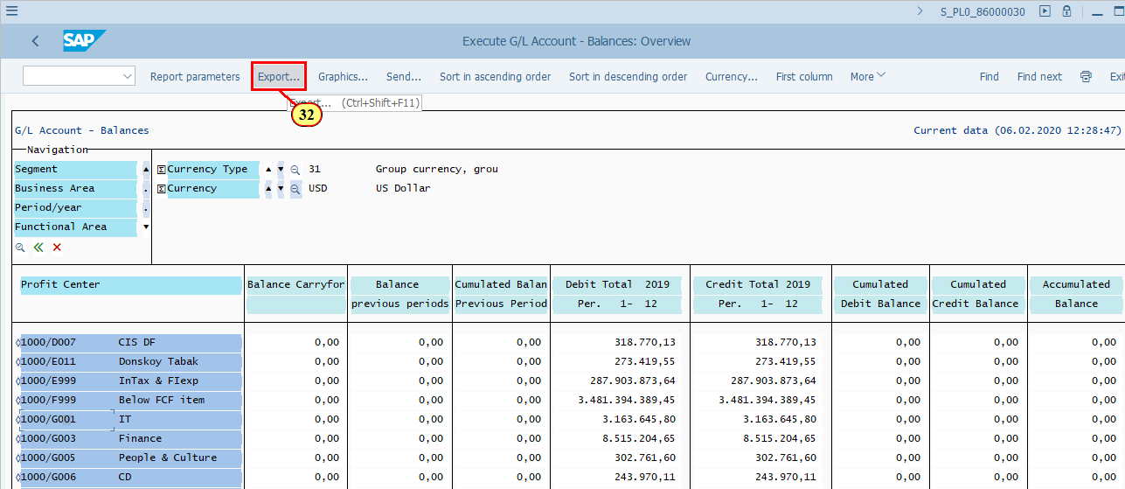
  Export  You can export the report via Export menu. But please bear in mind the following before doing so:  - It would be easier if you had selected Object List output type when you executed the report if you were going to export it. Although you can select "Object List" again here.  - You probably find CDS Views much easier if you want to get the same data in Excel and perform some further analysis.  Export menu allows you to export the report in various formats as shown on the screen.  - Copy report to XXL: All data of the report will be downloaded to Excel, with multiple lead columns. This effectively achieve the same result as if you download an Object List, but without the step of viewing the result first as Object List in SAP before saving it to Excel.  - Copy page to XXL: Only data shown based on current selection/filter criteria will be downloaded to excel, with the same lead column as currently shown.  - Save to file: Only data shown based on current selection/filter criteria will be downloaded to one of the formats, DAT, TXT, RTF, with the same lead column as currently shown.  - Object List: Use this option to switch from the classic drilldown report to Object List (as if you had executed the report using Object List output at the very beginning), then from Object List you can use standard SAP functionalities to download the report.  After you click one of the Export types, you can follow the standard steps to save the file to excel or other formats. These steps are common for many reports in SAP therefore are not specifically described in this simulation.  Click to continue.  [33] Click Copy report to XXL . | 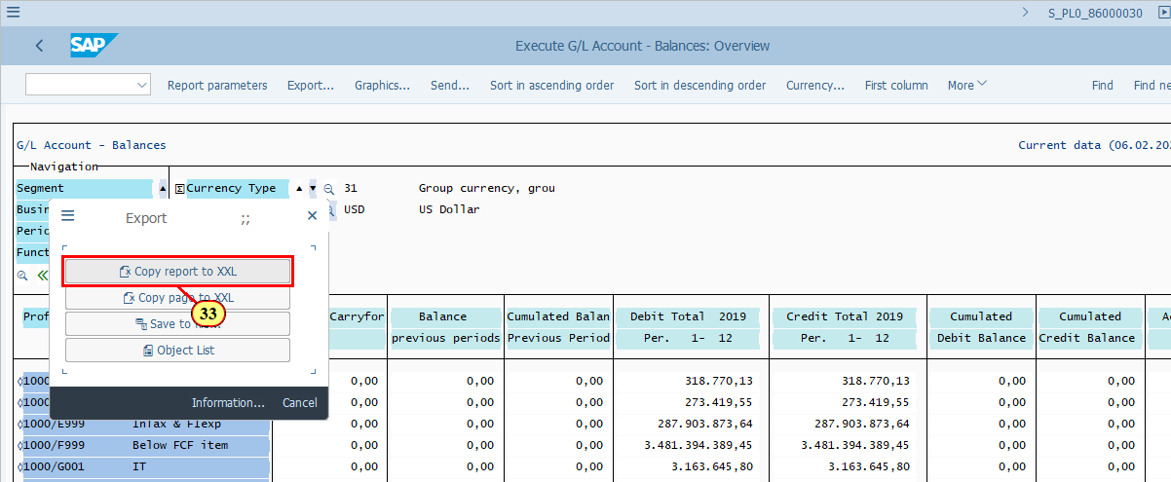
  Currency  This is a Display Currency, i.e. you can choose for the data in this report to be displayed in a specific currency of your choice. This can be any currency, which may have completely nothing to do with the selected data at all, as long as there's an exchange rate available in the system for the data to be converted to your chosen Display Currency.  Based on the above, in most of the cases this functionality is not commonly used. You may only consider using it if you are simulating some treasury related transactions using different rates (e.g. buying rate, selling rates, etc.) and a specific currency.  Click to continue.  [34] Click Currency... .  You can also press Ctrl+Shift+F4. | 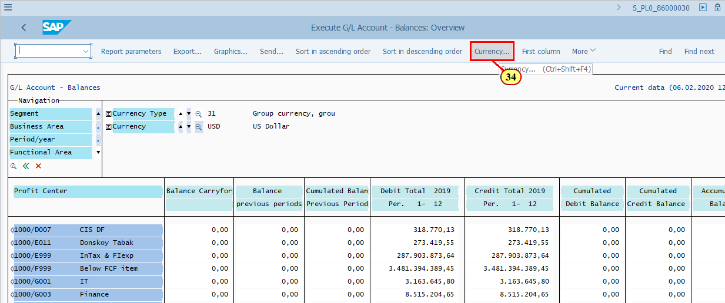
[35] Click the search icon next to Currency field to activate the dropdown list. | 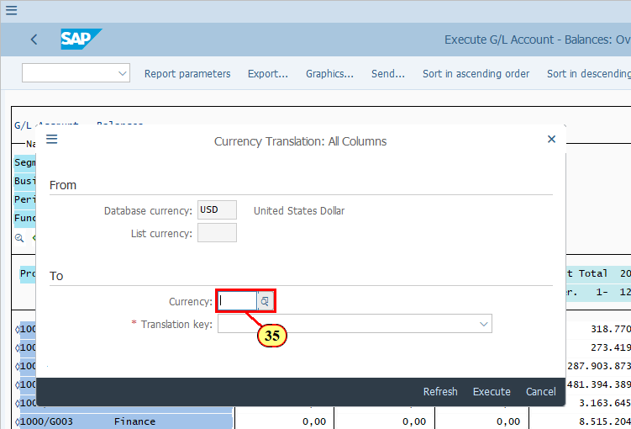
[36] is double-clicked. | 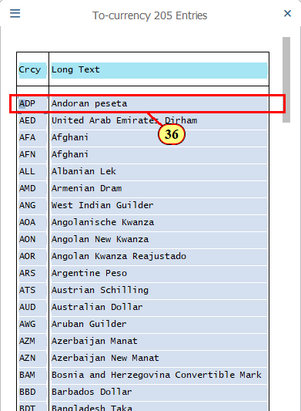
[37] Clicking the *Translation key button opens a dropdown list. | 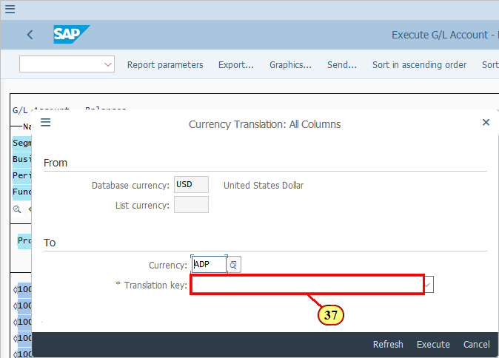
[38] Clicking the entry 1 Mean rate, as of today selects it. | 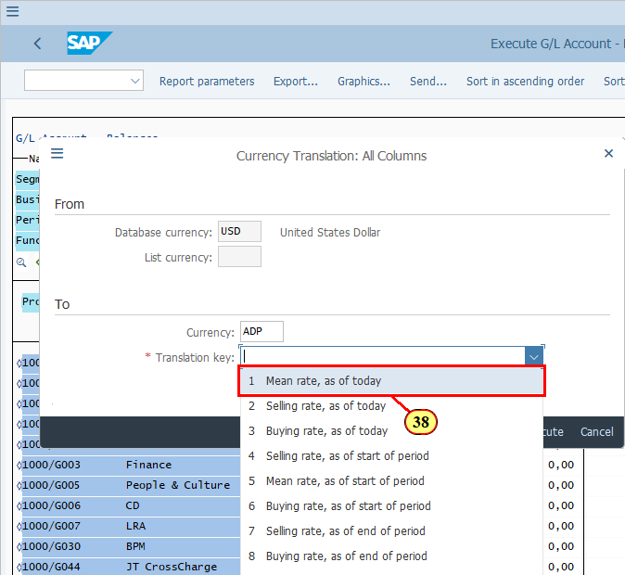
[39] Click Execute .  You can also press F8. | 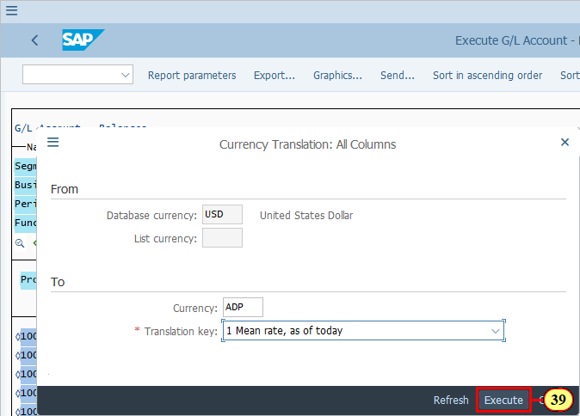
  Note that your selected rate may not always be available if you use Currency function randomly.  If your chosen currency and rate are available, data will be displayed in that currency.  [40] Click Continue .  You can also press Enter. | 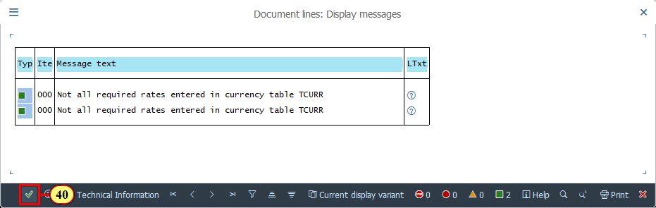
  To revert to Database Currency, either exit the report and execute it again, or open Currency menu to reset it.  [41] Click Database currency .  You can also press Ctrl+Shift+F12. | 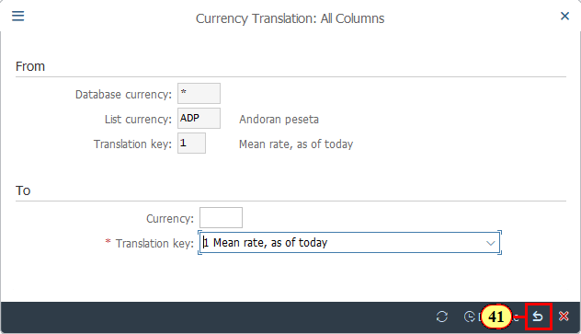
  One of the improvements in this report, as compared to the ECC Account Balance report, is that you can drill down to the line item details.  In our example, if we want to see the details of Debit Total of 2019 for JTIO/108100, we can click on the number shown here 1.357.809.080,59 and call up the line item report.  [42] Click 1.357.809.080,59 . | 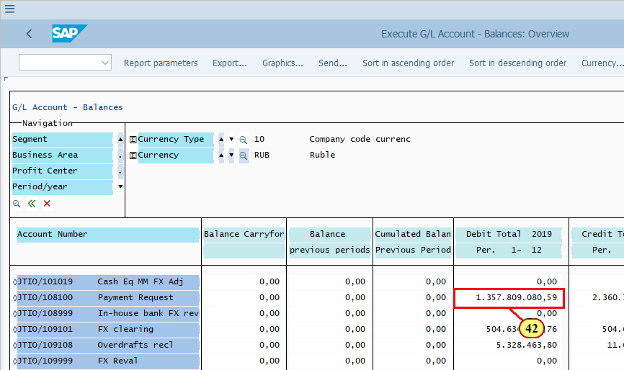
[43] Click Call up report... .  You can also press Ctrl+Shift+F3. | 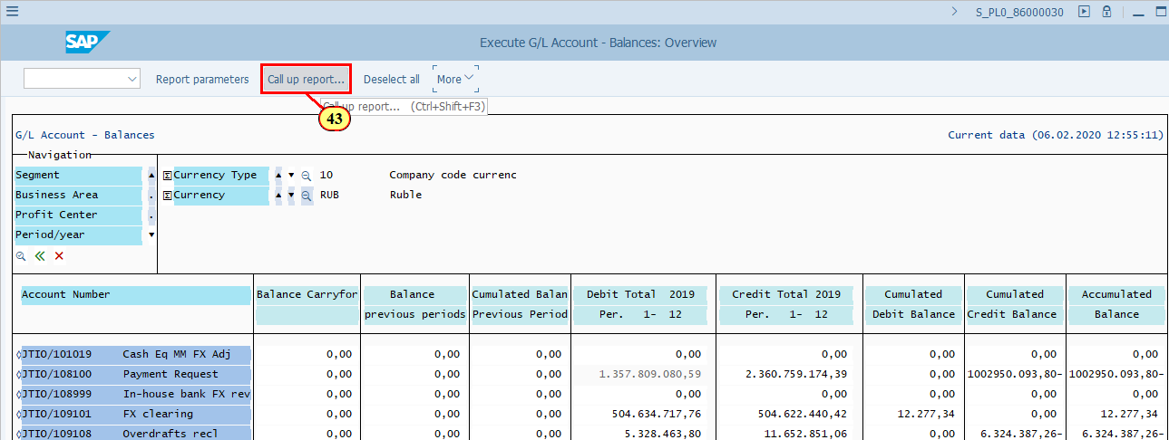
[44] Line Items is double-clicked. | 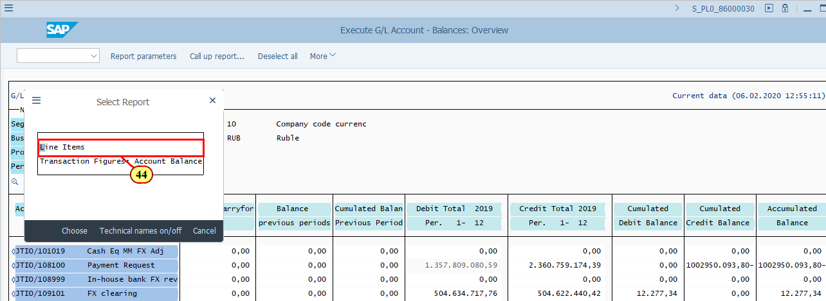
  Now you are in G/L Line Item report FAGLL03. Navigate in this report to see the total value, which should be the same as the value you selected in the Account Balance report. | 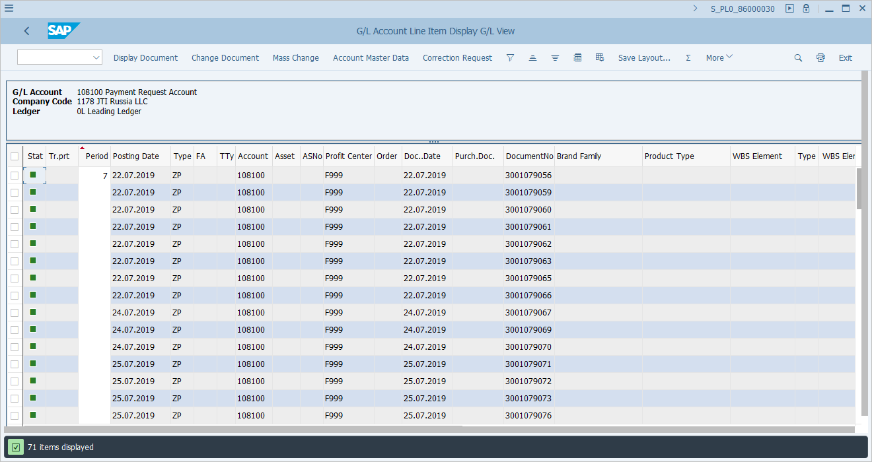
  This value is the same as the value you selected in the Account Balance report. You can review the detailed line items here before going back to the Account Balance report.  [45] Click Back .  You can also press F3. | 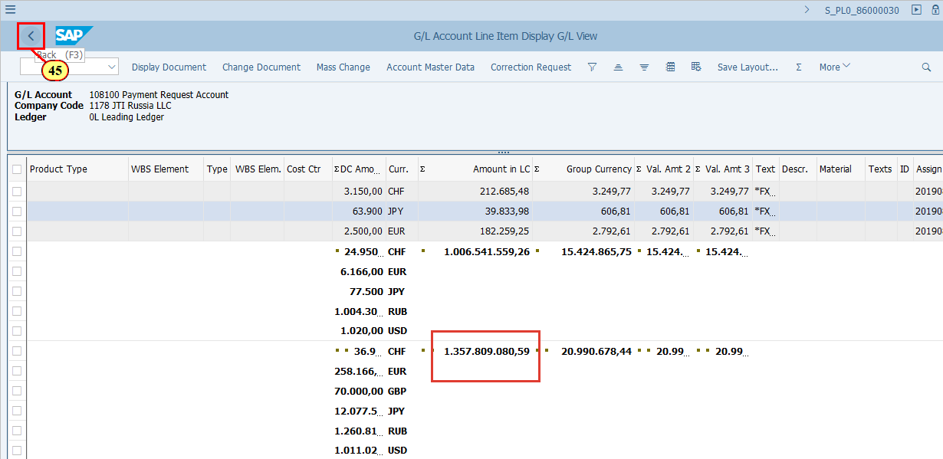
[46] Click Back .  to exit the report. You can also press F3. | 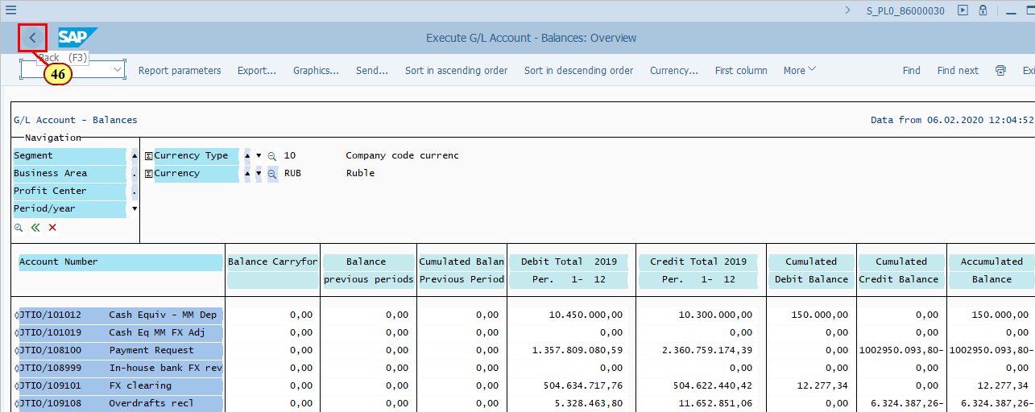
  It is a typical feature of SAP drilldown report that you have the opportunity to save the report definition together with the data from one execution and re-use it the next time when you execute the report with the same selection criteria. This will save time for the system as it does not need to extract the data again if you are happy to view the saved data. However you need to understand that the previously save data does not reflect the most up to date data in the system.  - You can do so by clicking on the "Save definition" button at the lower right hand corner of the report, or,  - you will be asked if you wish to save it when you exit the report. Choose Yes if you wish to save it.  As most of the users use this report for quick display of account balances at random times, you may not need to use the save definition/save data functionality.  Click to continue.  [47] Click No . | 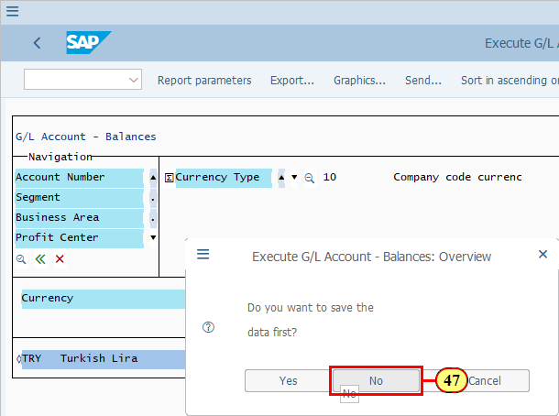
  Now let's have a look at the Graphical report output.  [48] Graphical report output is now selected. | 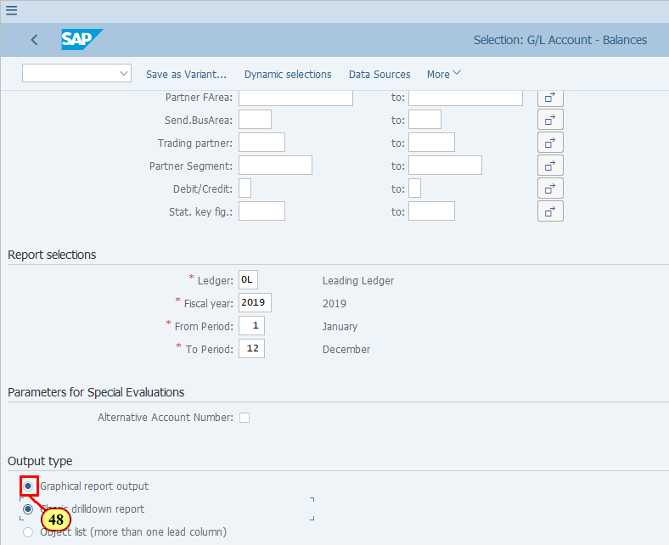
[49] Click Execute .  You can also press F8. | 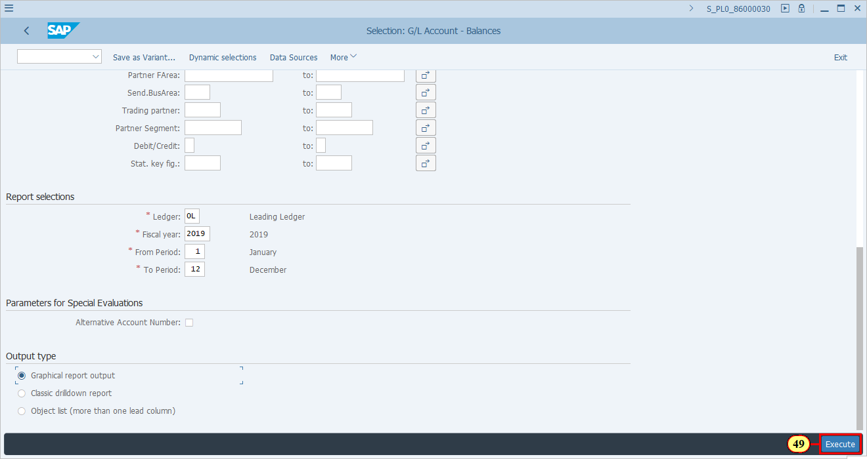
  As you can see, if one of the users (doesn't have to be yourself) have saved the report definition and data before, with the same selection criteria, when you execute the report again you will be asked if you want the system to select the data again (New selection) or you want to view the saved data.  - Select New selection if you want to view up to date data.  - Do Not save the report data if you do not have specific business requirement for that. | 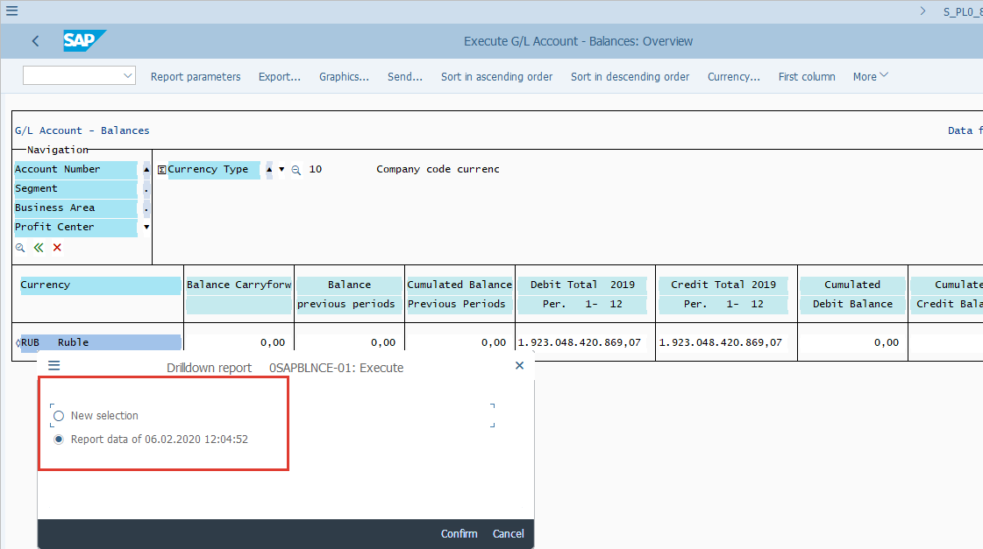
  In Graphical report output, the information is presented in a similar manner as in the Classic Drilldown report. Some users find it a little easier to use given the straight forward Navigation pane.  The Navigation pane lists all the characteristics (fields) available for the data you display, as well as the values that is currently being filtered for.  If you see a small arrow next to a characteristic, this means it is currently being filtered and you can move the arrow to see the data for the next value.  On the right hand side of the screen you have the data displayed based on your latest filters. | 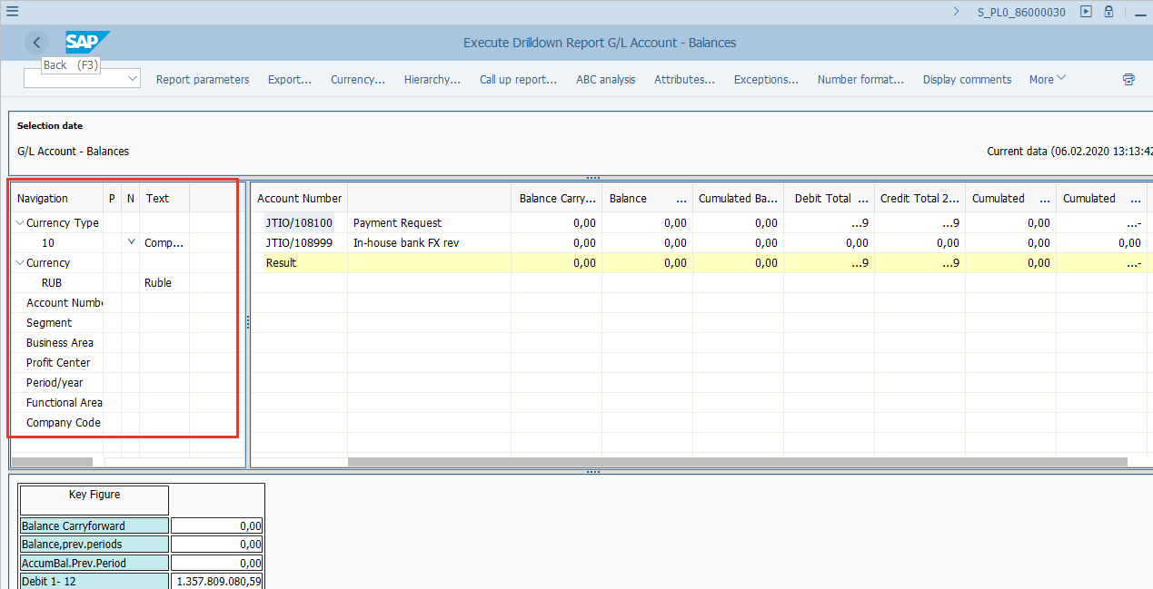
[50] Click to display data in the next Currency Type. | 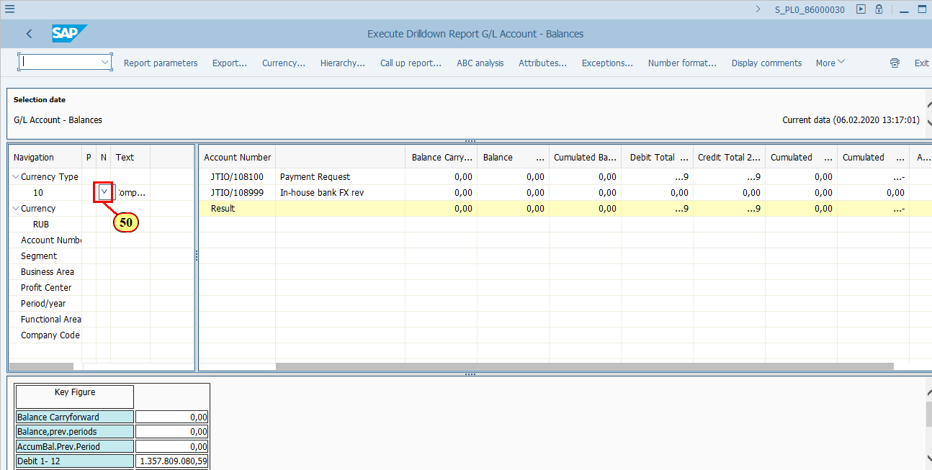
  Now the report is displayed in Currency Type 30 - USD. This information is shown in the Navigation pane.    The upper and lower arrows for a given Characteristic shown on the Navigation pane means the previous (P) or next (N) value to be filtered for. | 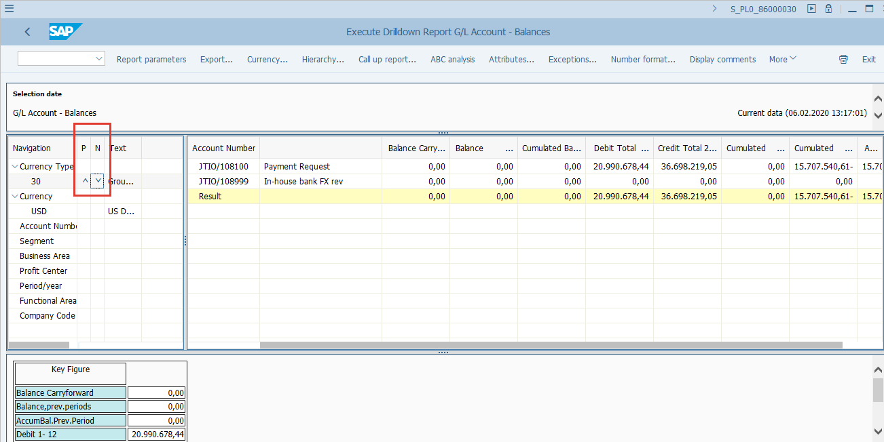
  If you wish to be able to see the breakdown of or filter for another Characteristic for the current value displayed, you simply double click the characteristic in the Navigation Pane.  E.g., we are now seeing the account balance by Account Numbers, now we want to see the breakdown of Profit Center. What we need to do is to double click Profit Center field in the Navigation pane.  [51] Profit Center is double-clicked. | 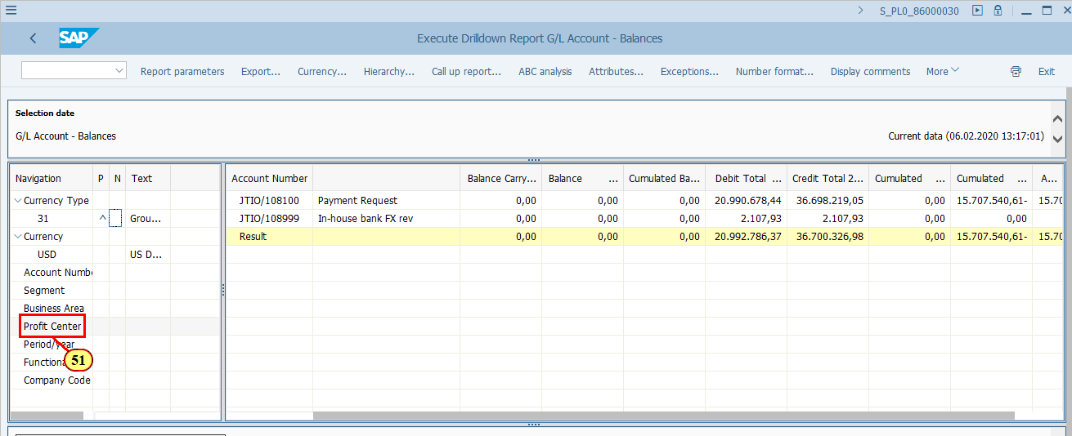
  Once we double clicked Profit Center, it was moved to the report area as Lead column. You can now see that all the balances are under Profit Center F999. The previous Lead column Account Number, is now moved back to the Navigation pane.  To swich back to Account Number as Lead column, double click Account Number from the Navigation pane.  [52] Account Number is double-clicked. | 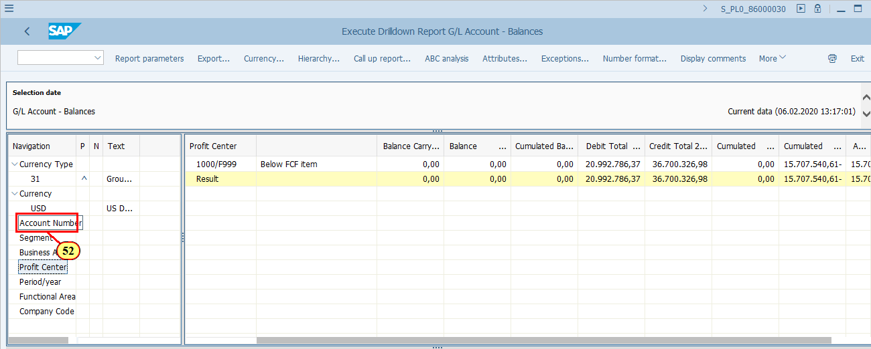
  If you wish to see the data with breakdown of both Account Number and Profit Center, you should double click the value in the current Lead column of the report.  E.g. we want to see the breakdown of the data belonging to JTIO/108999.  [53] JTIO/108999 is double-clicked. | 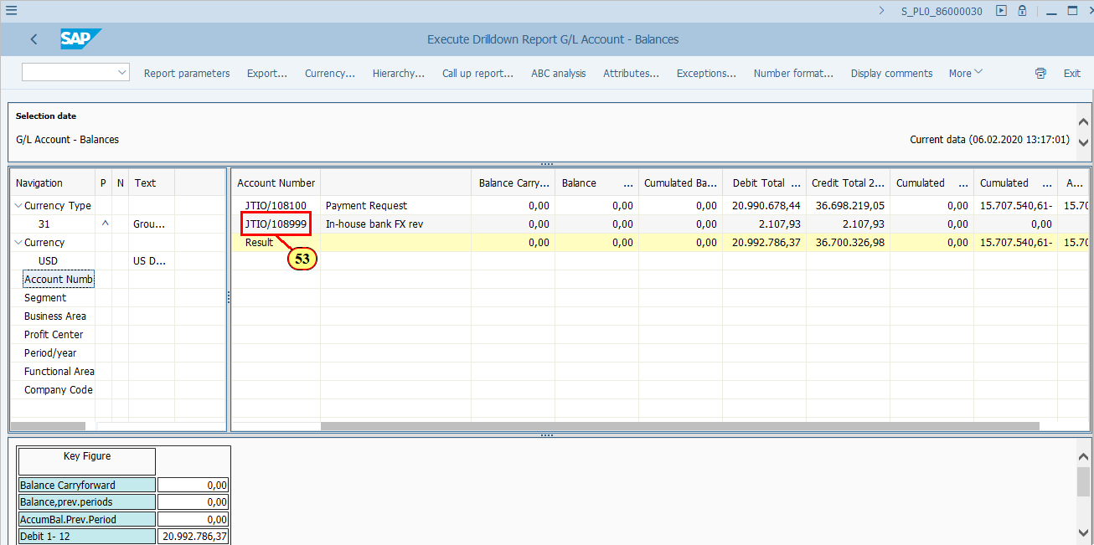
  You should notice two changes:  1. The selected JTIO/108999 has become a new filter and is shown in the Navigation pane.  2. The report Lead column has changed to Segment. As in JTI we do not use this field, there's no data assigned with any Segment value in the report. Why did the system choose characteristic Segment? It is because in this standard report Segment is the next field after Account Number in the Navigation pane. | 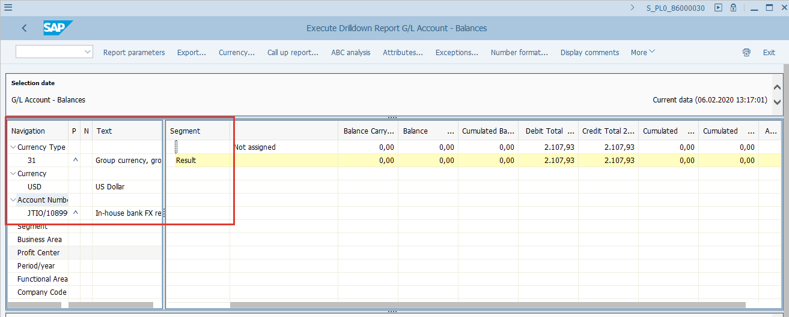
  Now, if we want to see the Profit Center values of the balances belonging to JTIO/108999, we simply double click Profit Center from the Navigation pane.  [54] Profit Center is double-clicked. | 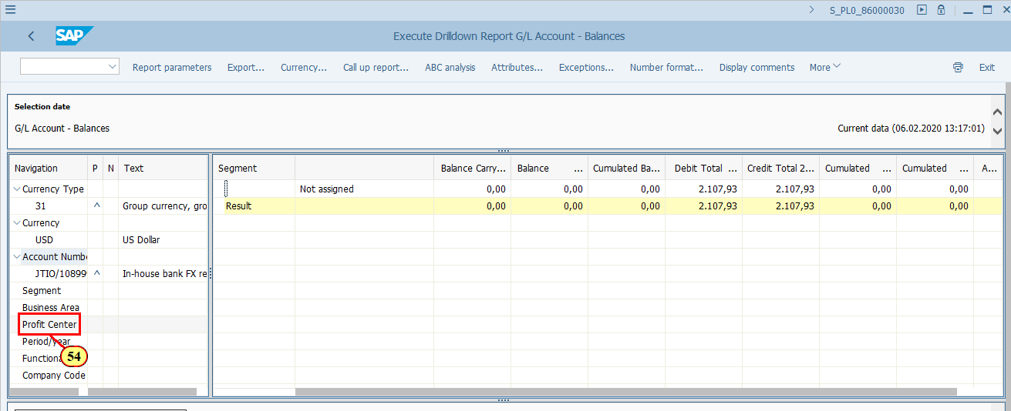
  Now, you can see the report data for your selected Currency Type and Account Number, with a breakdown of Profit Center.  You should notice that the Key Figure in the bottom of the report is updated accordingly too. | 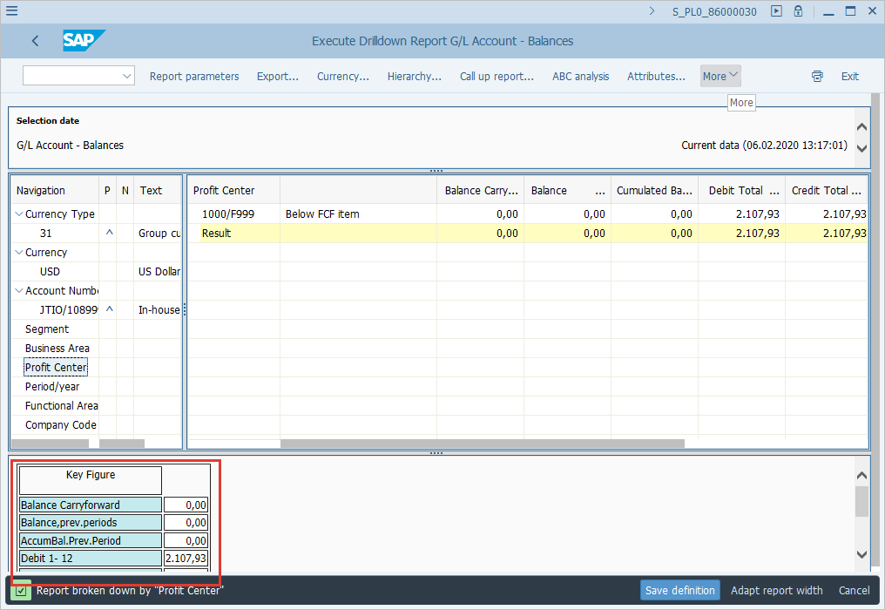
  You may notice that on the Lead column, we see both the Profit Center code and description. This doesn't have to be the same for everyone, as it can be changed in your own settings via More menu.  [55] Click More . | 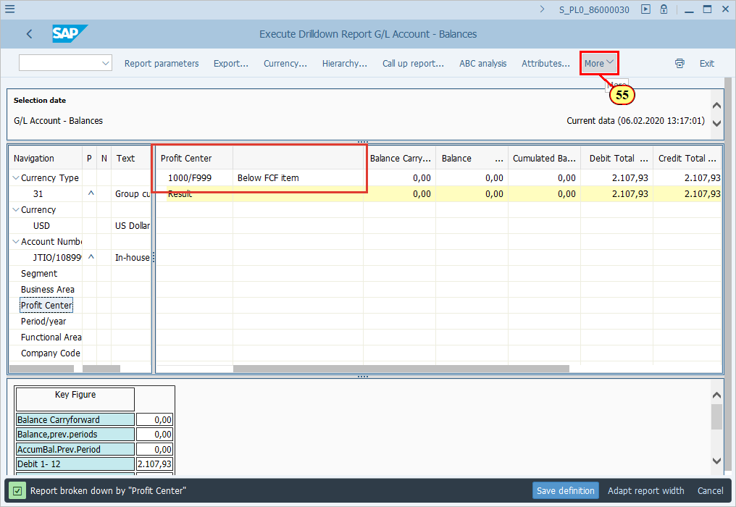
[56] Clicking the Characteristic display menu item executes it.  You can also press h. | 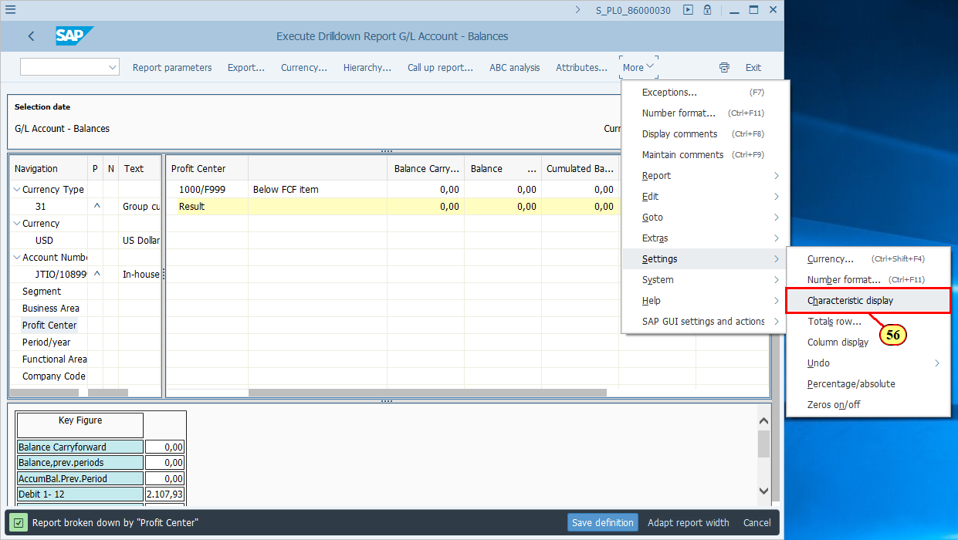
  Here you can decide whether you only wants to see the Key (e.g. the Profit Center code) or the Name (e.g. Profit Center short description), or both and in an order of your choice.  [57] Key is now selected. | 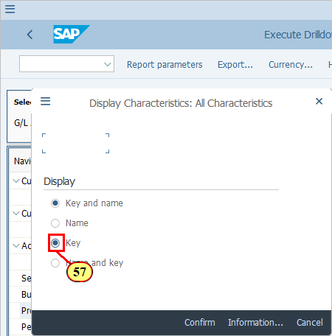
[58] Click Confirm .  You can also press F8. | 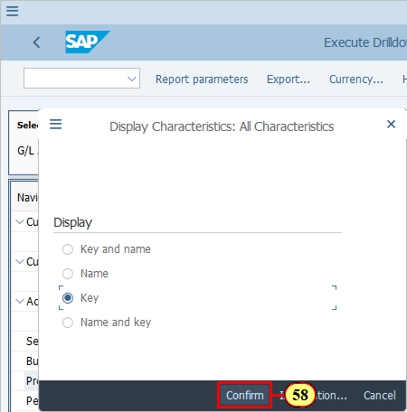
  As you can see, we selected only "Key", therefore only the Profit Center code is shown in the Lead column, without any description.  You may switch back to the previous setting by repeating the previous step and select Key and Name. | 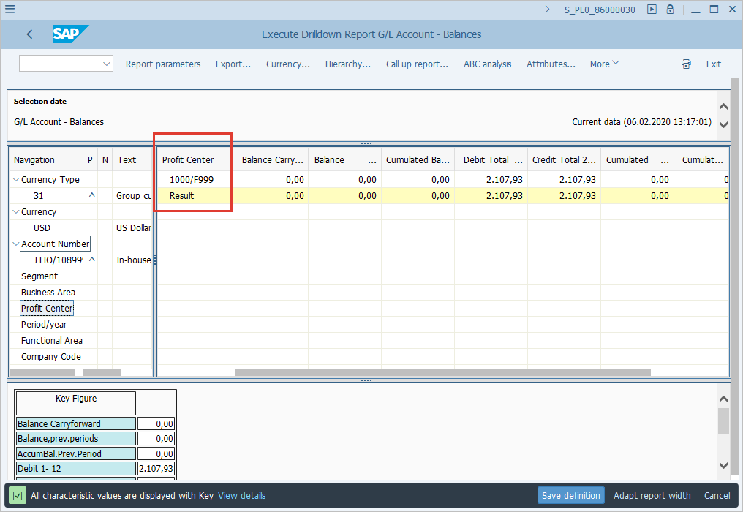
  You may try other various settings that are availale in the More menu. One of the settings you may want to use is to not display "0.00" on the report. Follow the example as demonstrated.  [59] Click More . | 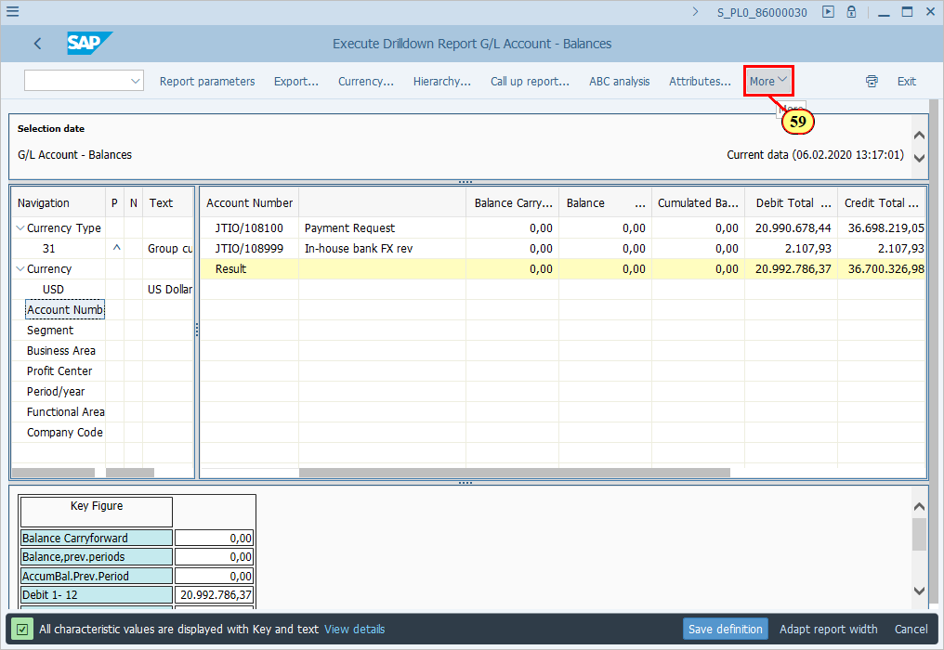
[60] Clicking the Zeros on/off menu item executes it.  You can also press n. | 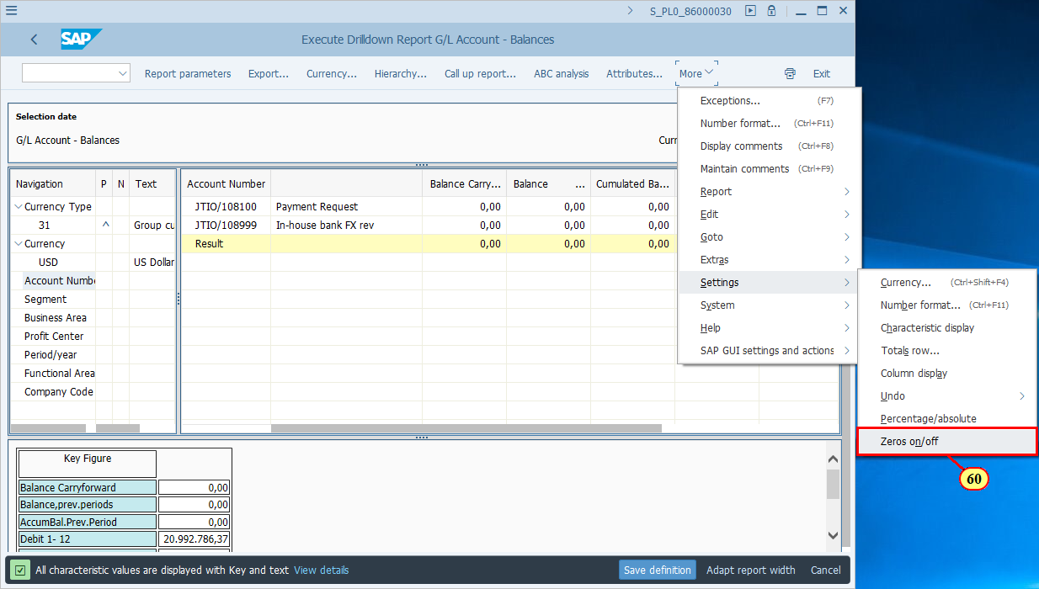
  As you can see the cells with zero values are simply blank without any value shown.  You may bring back the 0.00 by repeating the same menu path action. | 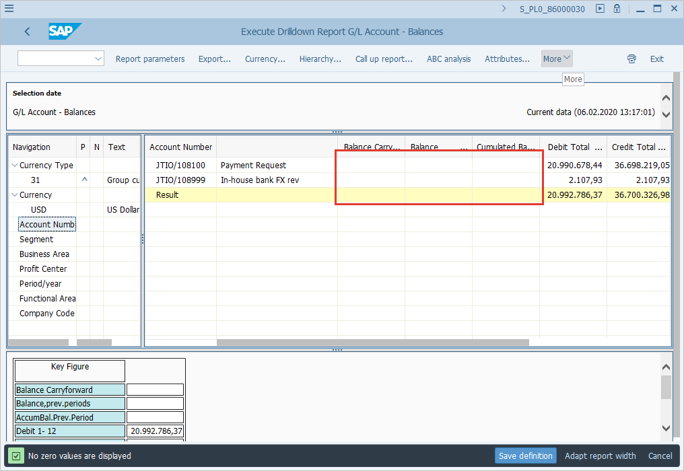
  Similar to Classic Drilldown report, you can export the report.  [61] Click Export... .  You can also press Ctrl+Shift+F12. | 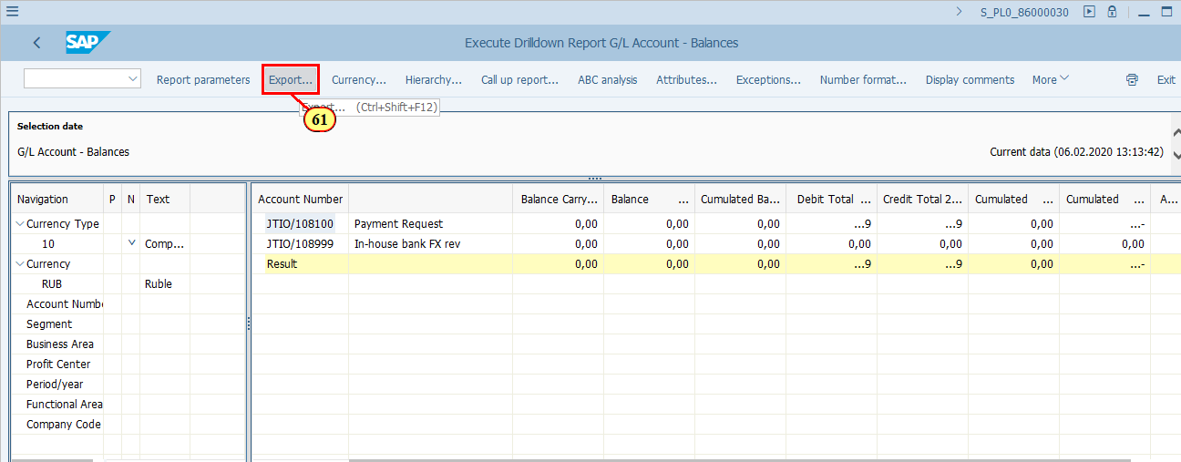
  The same formats are available for export from the Classic Drilldown output, with the exception of Save to file. Please refer to earlier explanations in Classic Drilldown output. | 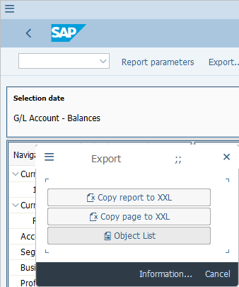
  Similar to Classic Drilldown output, you can also drill down a value in the report to line item details by using Call up report button. | 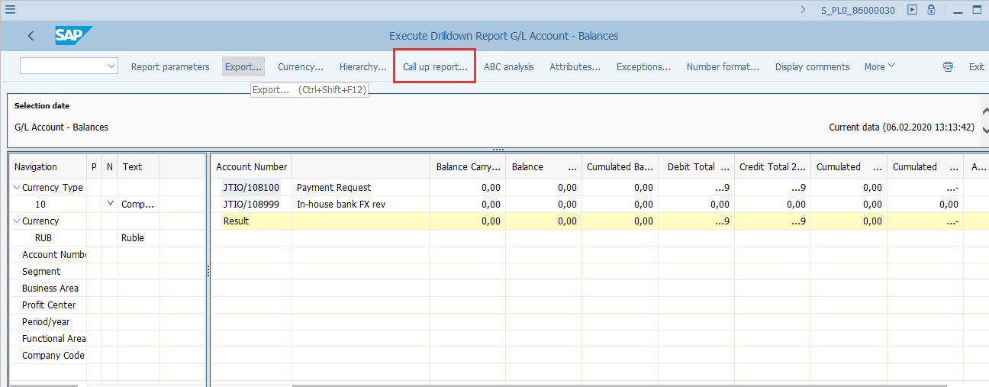
[62] Click Back .  You can also press F3. | 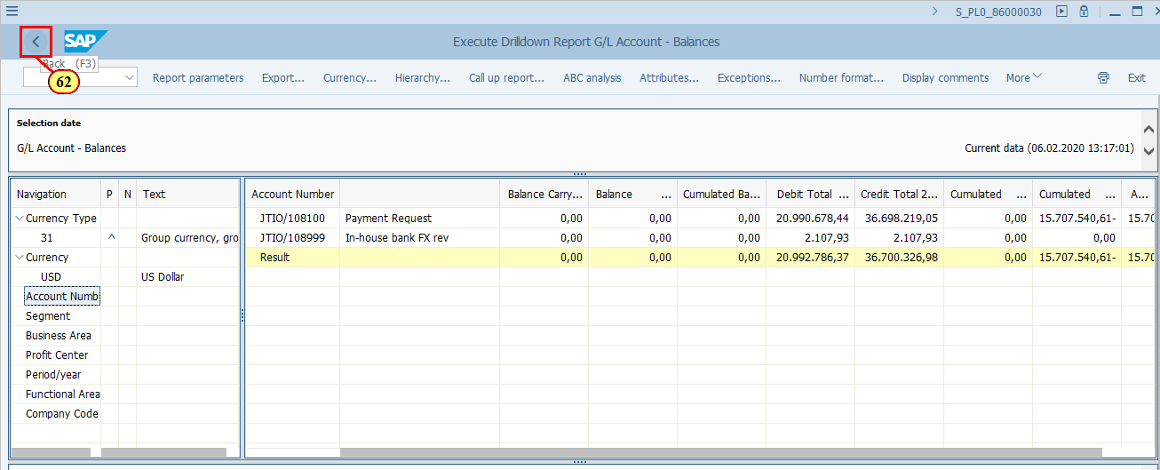
  You will be asked the same question regarding whether to save the data when you exit the report in Graphical report output. Click No unless you have specific business requirement to save the data.  [63] Click No . | 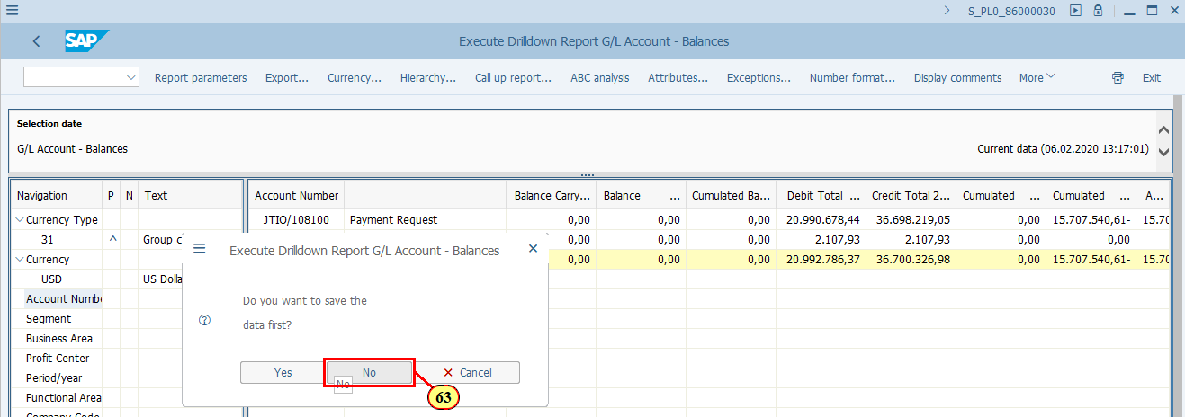
  Now let's take a look at the Object list output type.  Please be reminded that you can also switch from the previous two output formats (Graphical and Classic Drilldown) to Object list when you use Export function inside the report.  [64] Object list (more than one lead column) is now selected. | 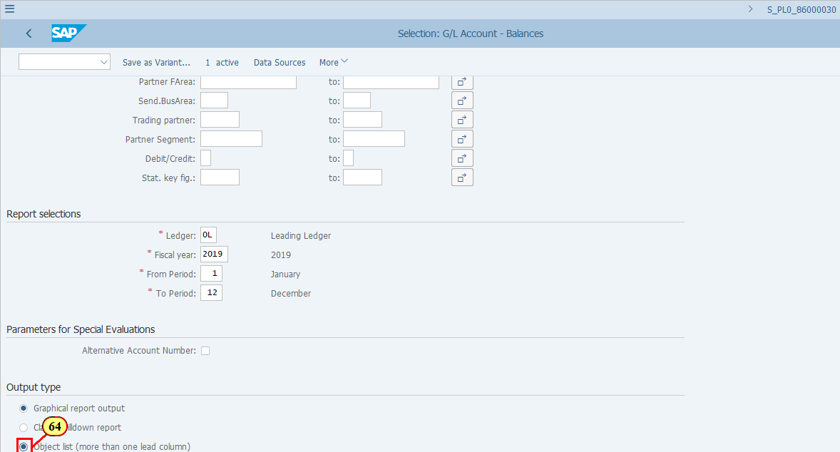
[65] Click Execute .  You can also press F8. | 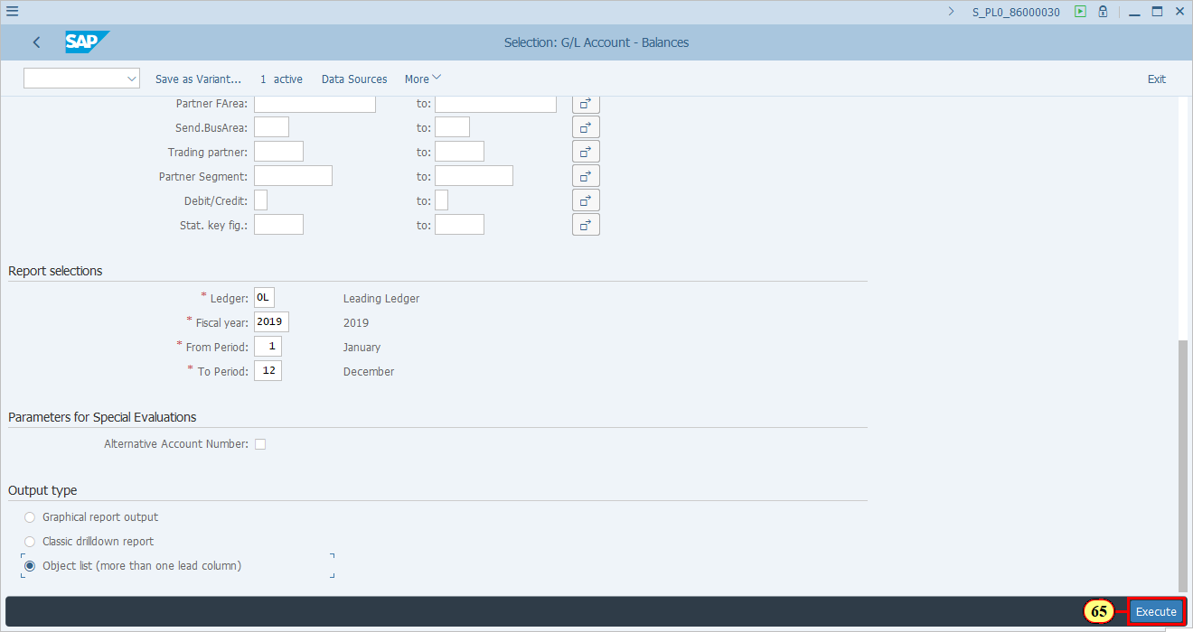
  You arrive at the same report format if you:  - have selected Object list output when you execute the report  - have selected Object list when you use Export function from the menu in the Classic Drilldown or Graphical report output.  Object list has more than one Lead columns in order to provide data in a tabular format with all the combinations based on your selection criteria.  You can use the standard report functions as in a standard SAP ALV Grid report, such as Total, Download, Change/Choose/Save layout, etc.  Click to continue. | 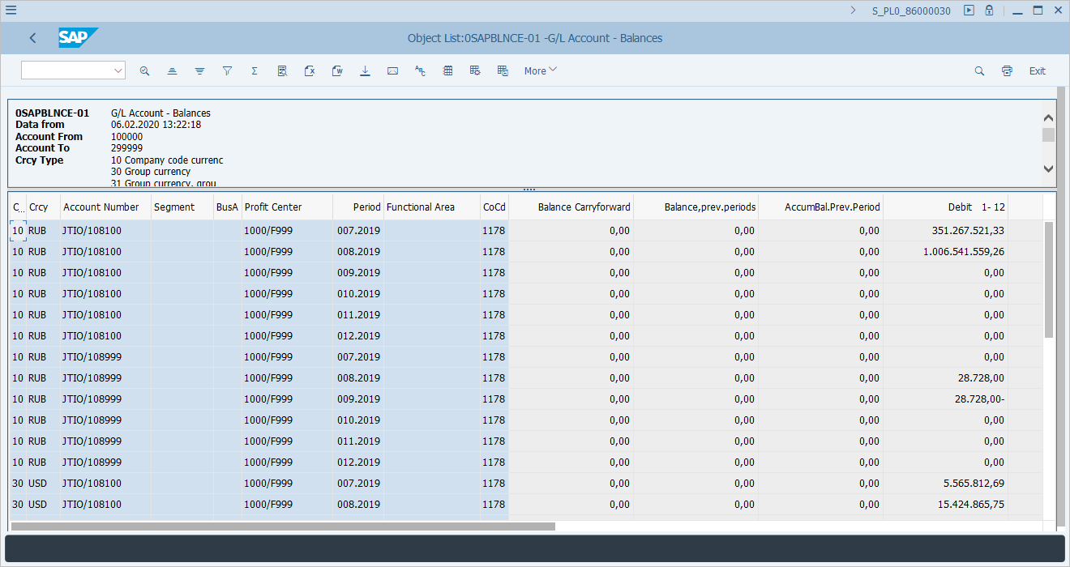
[66] Click Spreadsheet .  You can also press CTRL+SHIFT+F7. | 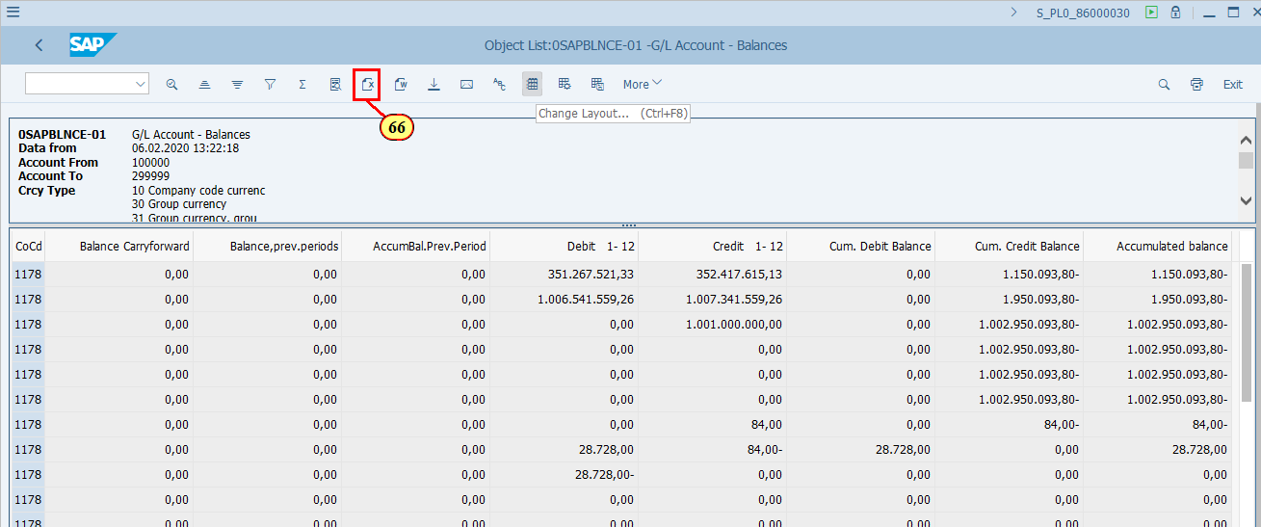
  Follow the standard download method from an SAP ALV list output report (not specifically described in this simulation)  [67] Clicking the entry 33 Excel - in existing XXL format selects it. | 